Dr. B.R. Ambedkar National Institute of Technology, Jalandhar -144011

A REPORT OF SIX WEEKS INTERNSHIP

At

**ADVANCE SOLUTIONS CORP., Jalandhar**

SUBMITTED IN PARTIAL FULFILLMENT OF THE REQUIREMENT FOR THE AWARD OF THE DEGREE OF

**BACHELOR OF Technology**

(Electronics and Communication Engineering)



SUBMITTED BY:

Name: Arun Bagga

Roll Number: 16106013

Table of Contents

|  |  |  |
| --- | --- | --- |
| **S.No.** | **Particulars** | **Page Number** |
| 1. | Abstract | 3 |
| 2. | Acknowledgement | 4 |
| 3. | About the company | 5 |
| 4. | Introduction to ServiceNow | 6-7 |
| 5. | Introduction to SDLC | 7-10 |
| 6. | Terminology used in ServiceNow | 10-28 |
| 7. | Project: Goals | 29 |
| 8. | Project: Analysis | 30 |
| 9. | Project: Working   * Customer Homescreen * Catalog * Ordering * Chef recieving order * Billing * Workflows * SLAs * Feedback * Backend Tables | 31-52  31-32  32-36  37-39  40-42  42-43  44-45  46-47  47-48  48-52 |
| 14. | Bibliography | 53 |

**ABSTRACT**

This report on ServiceNow Platform is a complete combination of theoretical knowledge and practical applications in the form of projects. India is a country where service based companies are generating much more revenues as compared to the product based companies. Under this trend, working under such a company as an intern is a useful experience. ServiceNow provides us a Platform as a Service (PaaS) to create dynamic Web Applications. This provides us a lot of in-built functionalities which make it one of the most popular platform worldwide.

In this report, the knowledge acquired about the ServiceNow platform during the training period is mentioned along with the Project undertaken. This was a team project in which a web application for “Restaurant Management” was built. This app was built for the internal organizational use and NOT for the ordering online. The customer can give food order which gets assigned to the chef based on the food category. User can monitor the preparation to serving process. Moreover if there is delay in serving the food, the manager gets notified and can take appropriate actions. There is also a feedback form for storing the customer reviews.

**ACKNOWLEDGEMENT**

I have taken efforts in this project. However, it would not have been possible without the kind support and help of many individuals and the organization. I would like to extend my sincere thanks to all of them.

I am highly indebted to ADVANCE SOLUTIONS CORP. for their guidance and constant supervision as well as for providing necessary information regarding the project & also for their support in completing the project.

I would like to express my gratitude towards Mr. Sanchit Sahni, Manager at Advance Solutions, Jalandhar and also our mentor Mr. Ratul Arora, Technical Consultant at Advance Solutions, Jalandhar for their kind co-operation and encouragement which help me in completion of this project.

Next thanks to my team who always encouraged me to explore a bit more of every topic. My thanks and appreciations also go to my colleague in developing the project and people who have willingly helped me out with their abilities.

**ABOUT THE COMPANY**

Founded in 2008, Advance Solutions Corp. is a ServiceNow Partner providing outstanding ServiceNow development, implementation, and deployment services to enterprise customers worldwide. This is a US based company with their offices expanding in USA, Singapore, Vancouver, Their goal is to make cloud-based service management quick and easy for their customers, ultimately improving company productivity, organization, and culture.

**ServiceNow** is an American cloud computing company with its headquarters in Santa Clara, California. It was founded in 2004 by Fred Luddy. ServiceNow is listed on the New York Stock Exchange and is a constituent of the Russell 1000 Index. It has many top IT Service Companies around the world as its partners such as HCL, TCS, Wipro. Advance Solutions Corp. is also one of them. Here the projects are gathered by a marketing team in US and are forwarded to teams of technical consultants across the world who develop the required application’s front end and back end functionalities. Using ServiceNow for application development has proved to be a lot more efficient and professional than working from the scratch because of the in-built functionalities (called “Out Of The Box features”). Moreover the platform has a well-defined documentation and an active Community to assist the developers who get stuck.

**WHAT IS SERVICENOW ?**

ServiceNow is a platform that provides its users with all the functionalities required to make any kind of cloud based service solutions. In servicenow, we have various modules that cover different parts of an application. Not all modules are required for making an application but more the modules involved more is the functionality domain of the Solution. ServiceNow has many different modules that cover different domains of a Service Product. A licensed developer is the one who has completed standard certification in atleast one module. These modules are:

* IT Service Management
* IT Operations Management
* IT Business Management
* Software Asset Management
* Security Operations
* Governance, Risk and Compliance
* Customer Service Management
* HR Service Delivery
* Analytics Intelligence and Reporting
* Now Platform

These modules as their names suggest perform the functions of internal as well as external management of an organization. From HR to IT, we can add any kind of functionality to our application. Many big companies like Microsoft Azure, AWS, Google Cloud, Alibaba Cloud etc. Also most of the Service based companies in India like TCS, HCL, and Wipro etc. also have distinguished ServiceNow teams that serve their clients who want their solutions in ServiceNow Platform.

ServiceNow platform has evolved a lot in the past decade and so. This platform has released a lot of versions. Each version comes with some added functionalities based on customer reviews. They release a version with the name of popular cities of world. The most recent edition is the Madrid release that came in April 2019. But before going to ServiceNow, SDLC should be covered.

**SDLC**

SDLC is a process followed for a software project, within a software organization. It consists of a detailed plan describing how to develop, maintain, replace and alter or enhance specific software. The life cycle defines a methodology for improving the quality of software and the overall development process.

The following figure is a graphical representation of the various stages of a typical SDLC.

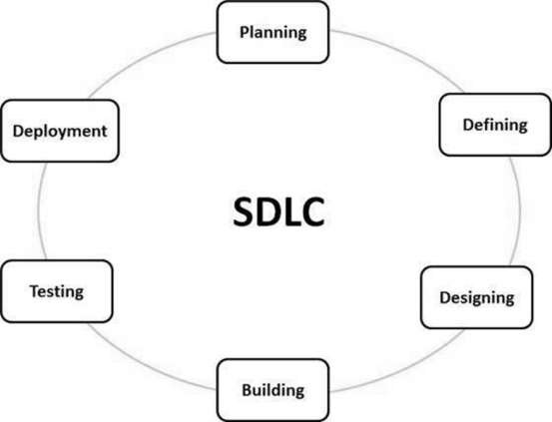

A typical Software Development Life Cycle consists of the following stages –

**Stage 1:** **Planning and Requirement Analysis**

Requirement analysis is the most important and fundamental stage in SDLC. It is performed by the senior members of the team with inputs from the customer, the sales department, market surveys and domain experts in the industry. This information is then used to plan the basic project approach and to conduct product feasibility study in the economical, operational and technical areas.

Planning for the quality assurance requirements and identification of the risks associated with the project is also done in the planning stage. The outcome of the technical feasibility study is to define the various technical approaches that can be followed to implement the project successfully with minimum risks.

**Stage 2: Defining Requirements**

Once the requirement analysis is done the next step is to clearly define and document the product requirements and get them approved from the customer or the market analysts. This is done through an **SRS (Software Requirement Specification)** document which consists of all the product requirements to be designed and developed during the project life cycle.

**Stage 3: Designing the Product Architecture**

SRS is the reference for product architects to come out with the best architecture for the product to be developed. Based on the requirements specified in SRS, usually more than one design approach for the product architecture is proposed and documented in a DDS - Design Document Specification.

This DDS is reviewed by all the important stakeholders and based on various parameters as risk assessment, product robustness, design modularity, budget and time constraints, the best design approach is selected for the product.

A design approach clearly defines all the architectural modules of the product along with its communication and data flow representation with the external and third party modules (if any). The internal design of all the modules of the proposed architecture should be clearly defined with the minutest of the details in DDS.

**Stage 4: Building or Developing the Product**

In this stage of SDLC the actual development starts and the product is built. The programming code is generated as per DDS during this stage. If the design is performed in a detailed and organized manner, code generation can be accomplished without much hassle.

Developers must follow the coding guidelines defined by their organization and programming tools like compilers, interpreters, debuggers, etc. are used to generate the code. Different high level programming languages such as C, C++, Pascal, Java and PHP are used for coding. The programming language is chosen with respect to the type of software being developed.

**Stage 5: Testing the Product**

This stage is usually a subset of all the stages as in the modern SDLC models, the testing activities are mostly involved in all the stages of SDLC. However, this stage refers to the testing only stage of the product where product defects are reported, tracked, fixed and retested, until the product reaches the quality standards defined in the SRS.

**Stage 6: Deployment in the Market and Maintenance**

Once the product is tested and ready to be deployed it is released formally in the appropriate market. Sometimes product deployment happens in stages as per the business strategy of that organization. The product may first be released in a limited segment and tested in the real business environment (UAT- User acceptance testing).

Then based on the feedback, the product may be released as it is or with suggested enhancements in the targeting market segment. After the product is released in the market, its maintenance is done for the existing customer base.

**Basic Terminology used in ServiceNow:**

1. **Tables (sys_db_object):** Tables are available to store instance data. Each table stores a collection of records. Each row corresponds to a single record, and each column corresponds to a field. Applications use tables and records to manage data and processes.

*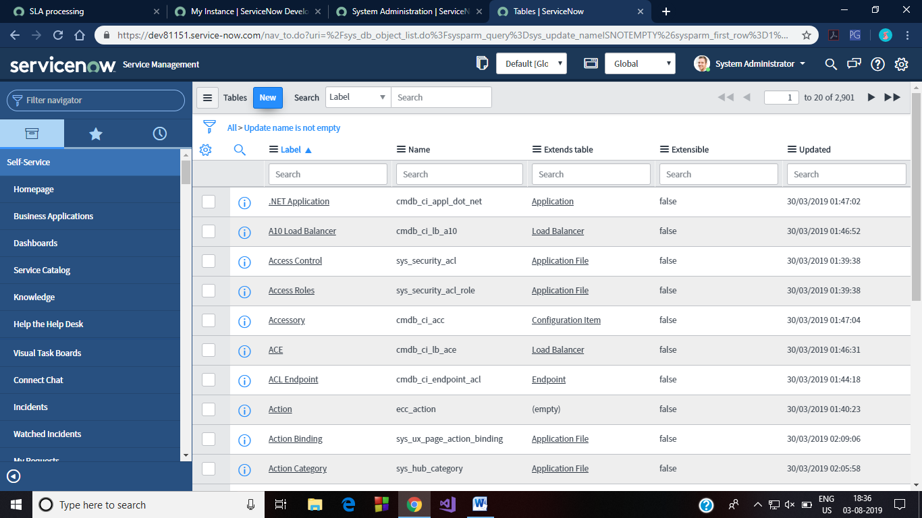Figure 1 Default Tables in Instance*

1. **Table Column (sys_dictionary):** Controls to specify the properties of database tables and columns such as data type, length, and default value.

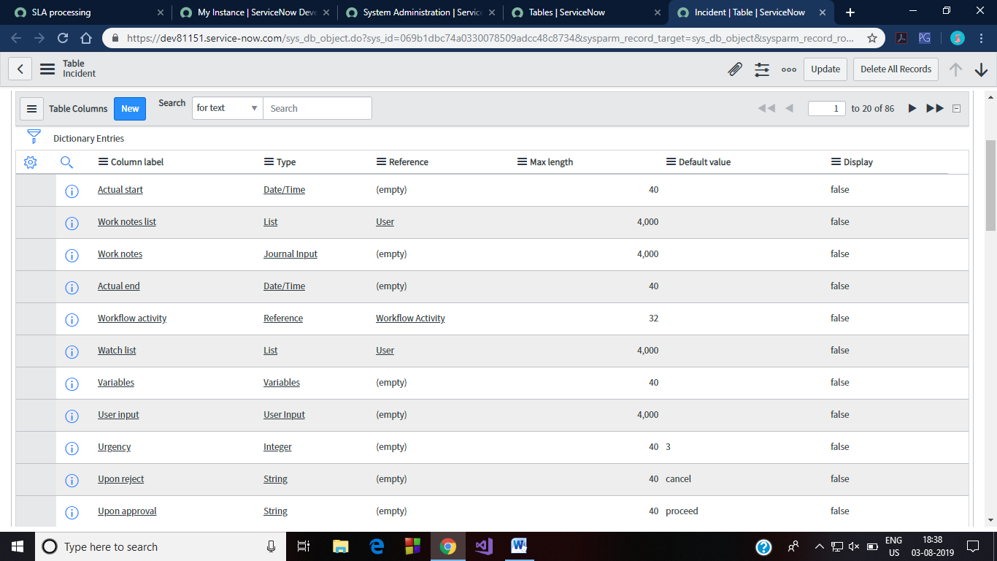*Figure 2 Table Columns/Fields in Incident Table*

1. **Form (sys_ui_form):** Controls to specify what fields to show on a form for a particular view or user.

*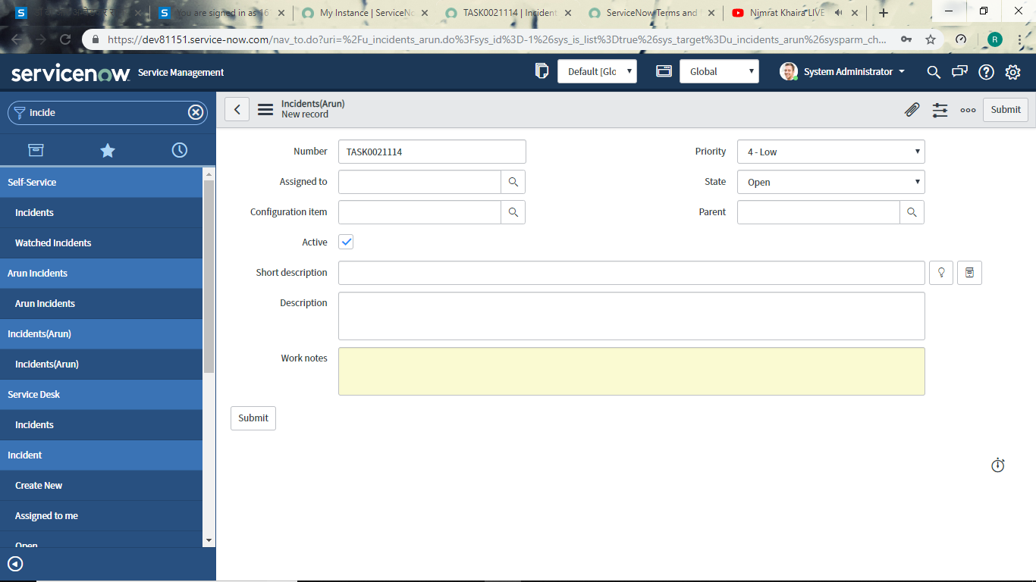Figure 3 Incident Form: Filling this form creates an entry in incident table*

1. **List Layout (sys_ui_list):** Controls to specify what columns to show on a list for a particular view or user.
2. **Related List (sys_ui_related_list):** Related lists display records in another table that have a relationship to the current record. Users can view and modify information in related lists using standard list controls.

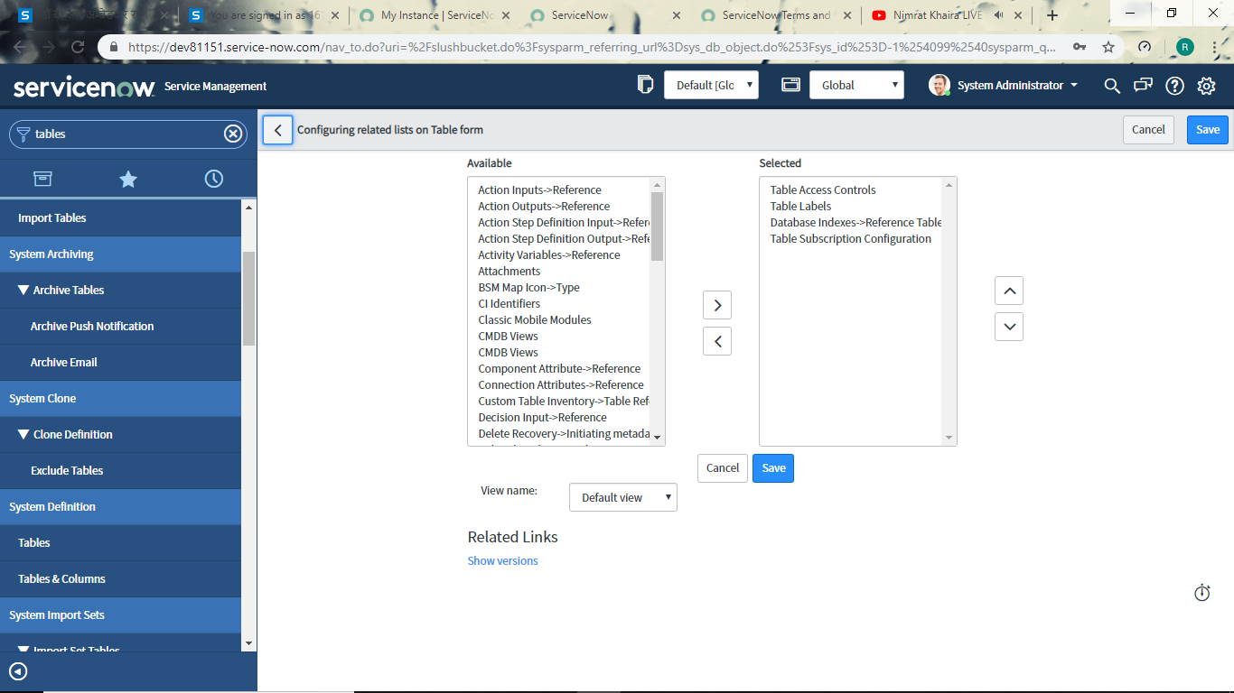

Figure 4 Related Lists on Incident table.

1. **Context Menu (sys_ui_context_menu):** Controls to create a custom link in a list or form's contextual menu to perform a particular action.
2. **Template (sys_template):** Controls to pre-populate particular forms with record data

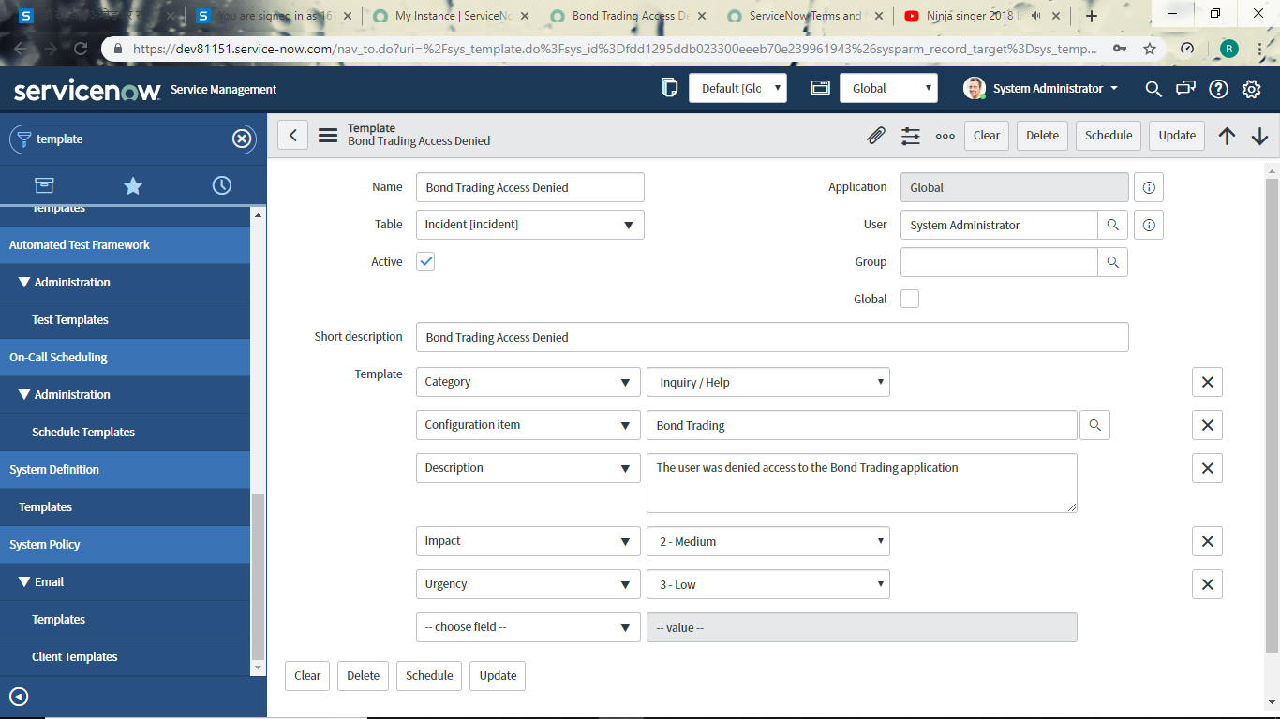 *Figure 5 Example of template: This provides us a pre filled form.We can customize/modify according to our need*

1. **Guided Tour (sys_embedded_tour_guide):** Provides a way to demonstrate to users how to use a feature or perform a task in the platform. You create a set of tour steps with callouts that point to appropriate UI elements, and provide the description or instruction to proceed. You select a specific event as a trigger in each step to advance to the next step.
2. **Business Rule (sys_script):** Business logic to execute in response to an operation against a particular database record. These business rules may take declarative actions or include arbitrary scripting.

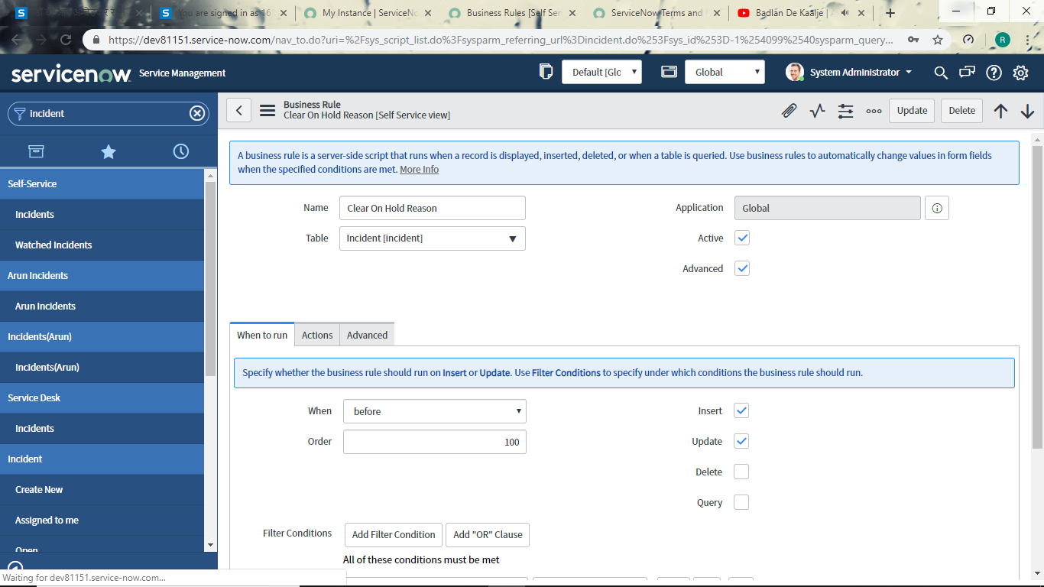

Figure 6 This business rule deletes previous On Hold Reason when state of incident is changed from On-Hold to something else

1. **Data Policy (sys_data_policy2):** Rules to enforce data integrity and policy
2. **UI Script (sys_ui_script):** UI scripts provide a way to package client-side JavaScript into a reusable form, similar to how script includes store server-side JavaScript. Administrators can create UI scripts and run them from client scripts and other client-side script objects and from HTML code.
3. **UI Action (sys_ui_action):** Controls to create a custom button or link on lists or forms to perform a particular action.

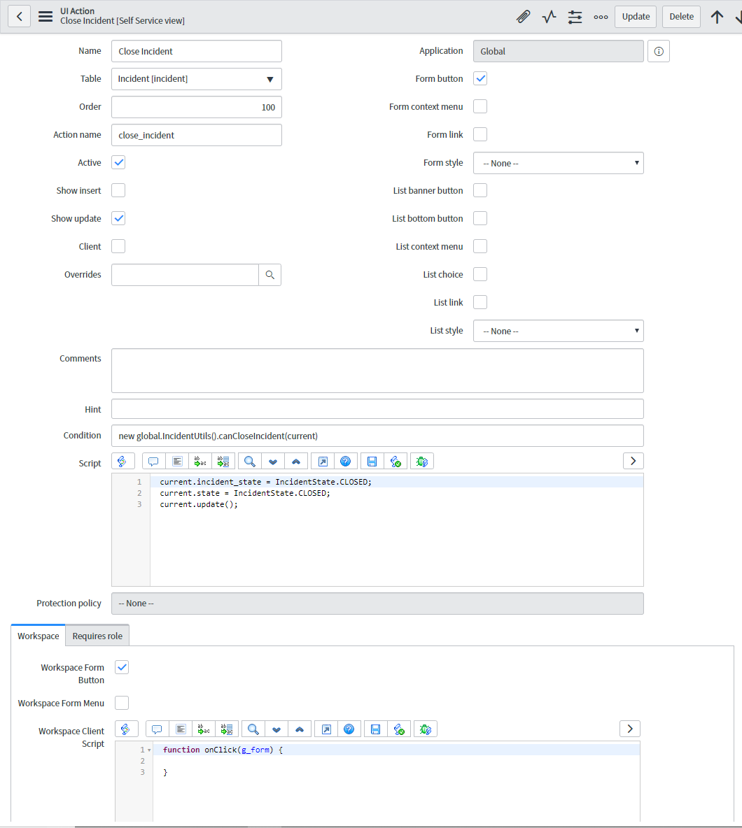

Figure 7 UI Action for Close Incident Button

1. **Client Script (sys_script_client):** Client-side JavaScript for running business logic on forms when certain browser events occur

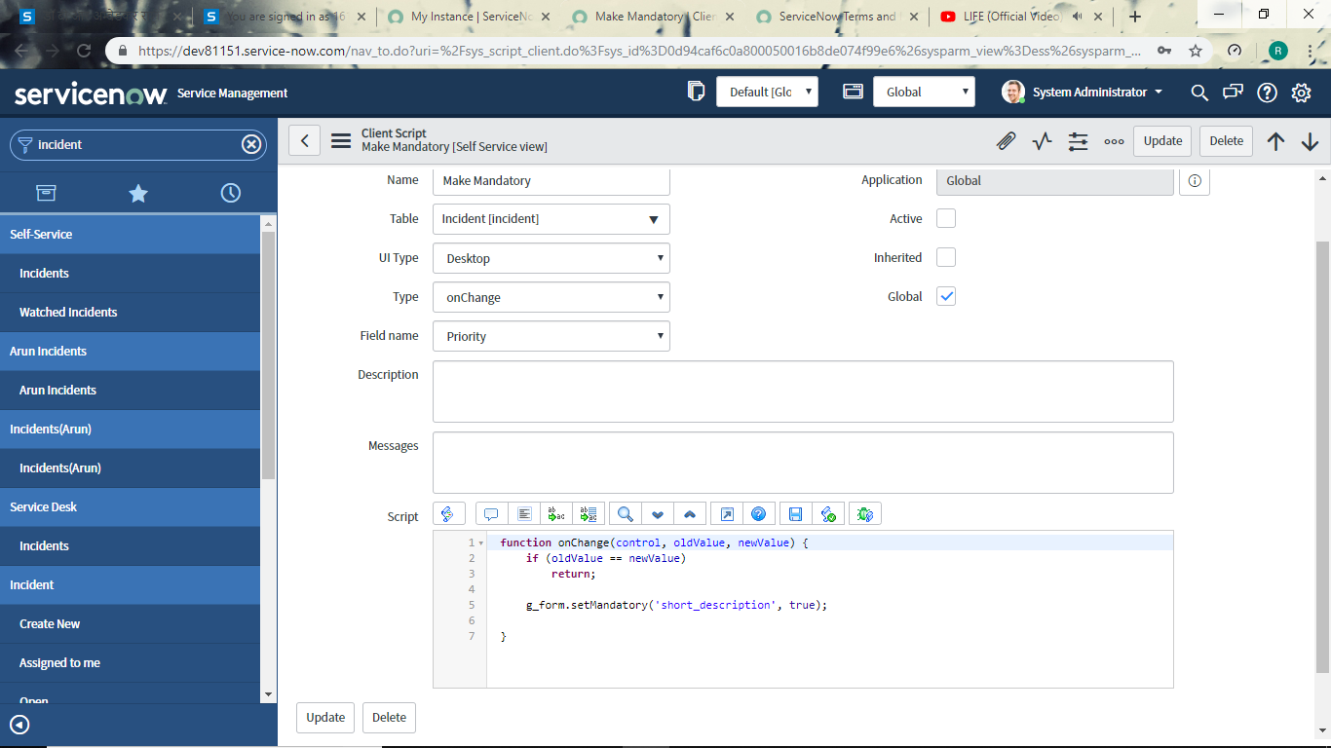

Figure 8 Client Script to make short_description a mandatory field

1. **UI Policy (sys_ui_policy):** Controls to specify what fields are visible and editable on a form based on its current content
2. **Assignment Data Lookup (dl_u_assignment):** Rules for assigning incidents based on certain value combinations
3. **Data Lookup Definitions (dl_definition):** Controls for automatically changing records values based on data lookup rules
4. **Priority Data Lookup (dl_u_priority):** Rules for setting incident priority based on certain value combinations

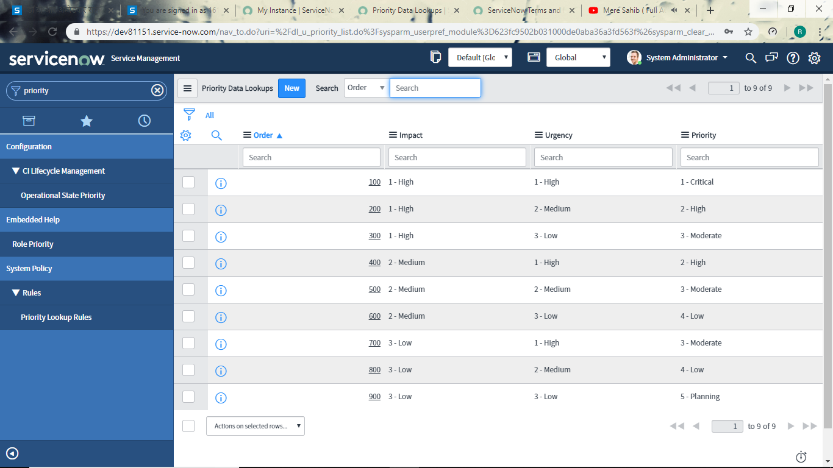*Figure 9 Priority data lookup*

1. **Role (sys_user_role):** Security tokens to control access to user interface elements such as menus, modules, tables, and field.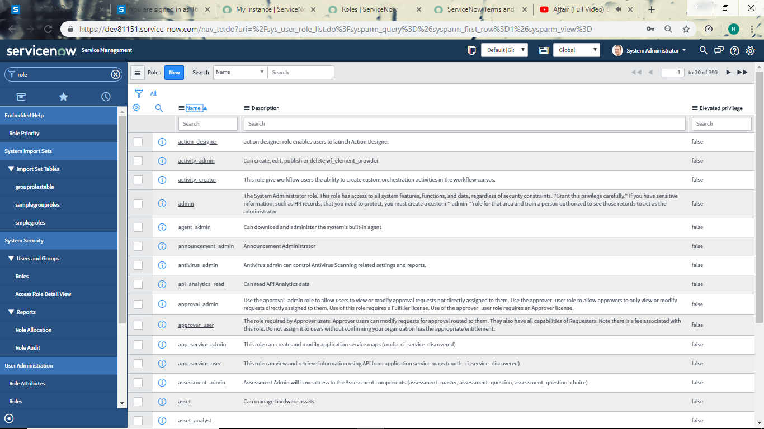
2. **Application Menu(sys_app_application):** Application menus available for the application navigator
3. **Module (sys_app_module):** Links available to display within application menus

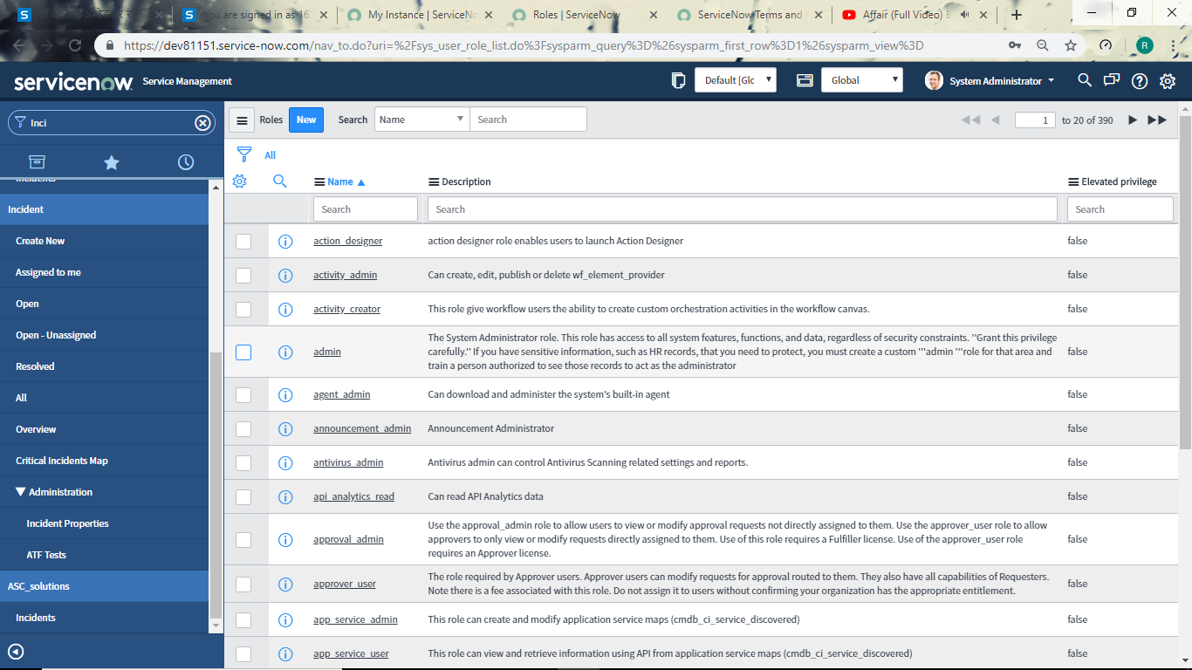

Figure 10 Here 'Incident' is Applicaion menu and below are its modules

1. **Notification (sysevent_email_action):** Email notifications available to the system
2. **Email Template (sysevent_email_template):** Templates for creating email notifications
3. **Service Portal (sp_portal):** Service Portal is the default webpage that is given out of the box by ServiceNow. This webpage has a search bar, link to service catalog items, knowledge base articles, community, user’s requests, approvals, incidents raised, popular requests etc. This page can be easily modified by adding new widgets at whichever place the user desires. Moreover we create this page differently for different users.

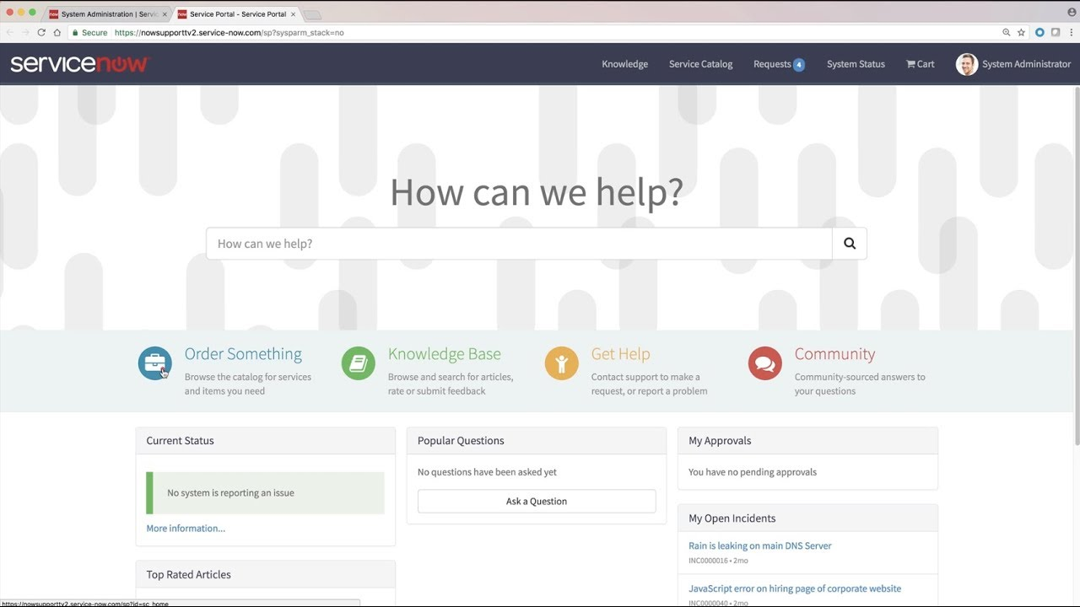

Figure 11 Degault Service Portal home page

1. **Widget (sp_widget):** A widget is a component of a webpage. A webpage is comprised of various widgets arranged in a container. There are a lot of widgets given by ServiceNow out of the box. Also we can create our personalized widget by a little knowledge of Angular. These widgets can either be for display purposes or they can have some functionality with the backend tables. The functionalities can be seen and modified in the widget editor.

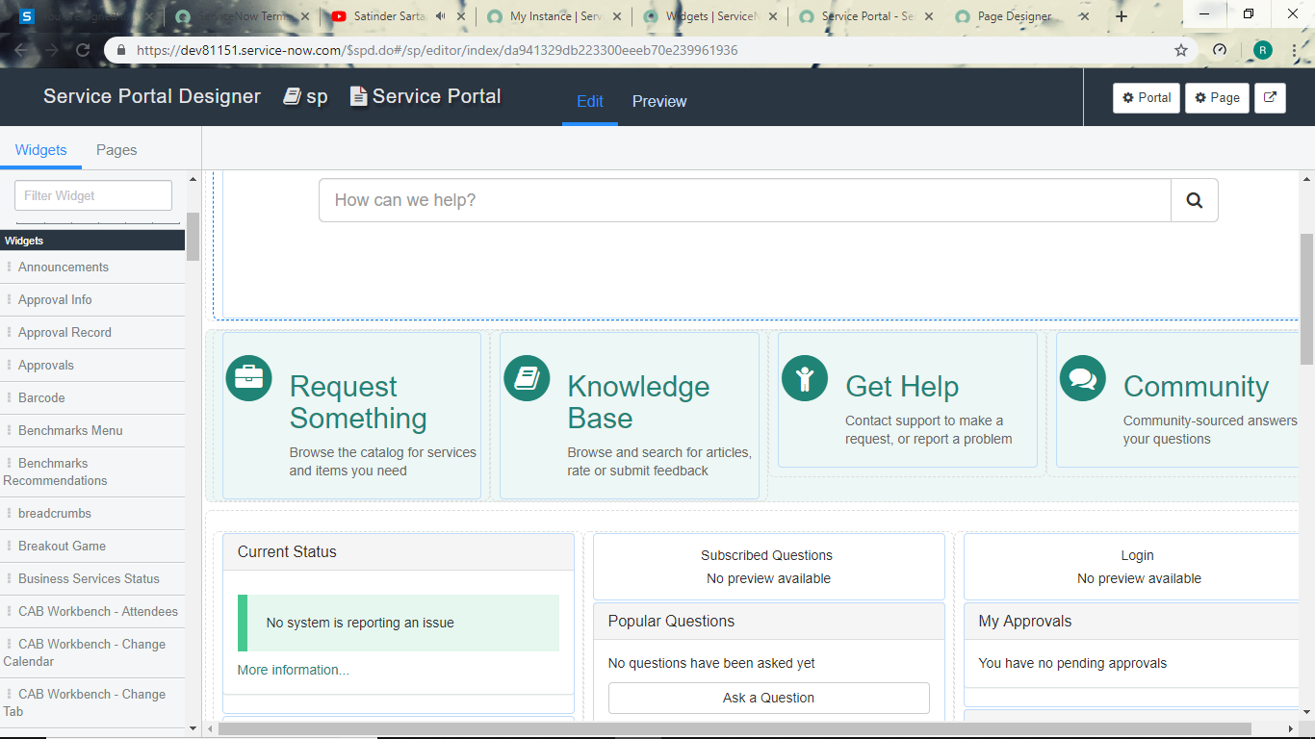

Figure 12 list of Widgets are shown in the left

1. **Catalog item (sc_cat_item):** Catalog items available to the Service Catalog are placed here. The data of these items consist of their price, workflow associated, description and short description, etc.
2. **Category (sc_category):** Categories are maintained to organize Service Catalog Items. We can have as many categories and as many catalog items in each category as we want.
3. **Catalog (sc_catalog):** Items and services end users can order from a catalog. These catalogs can contain categories. For example: Service Catalog has categories like: Hardware, Software etc.

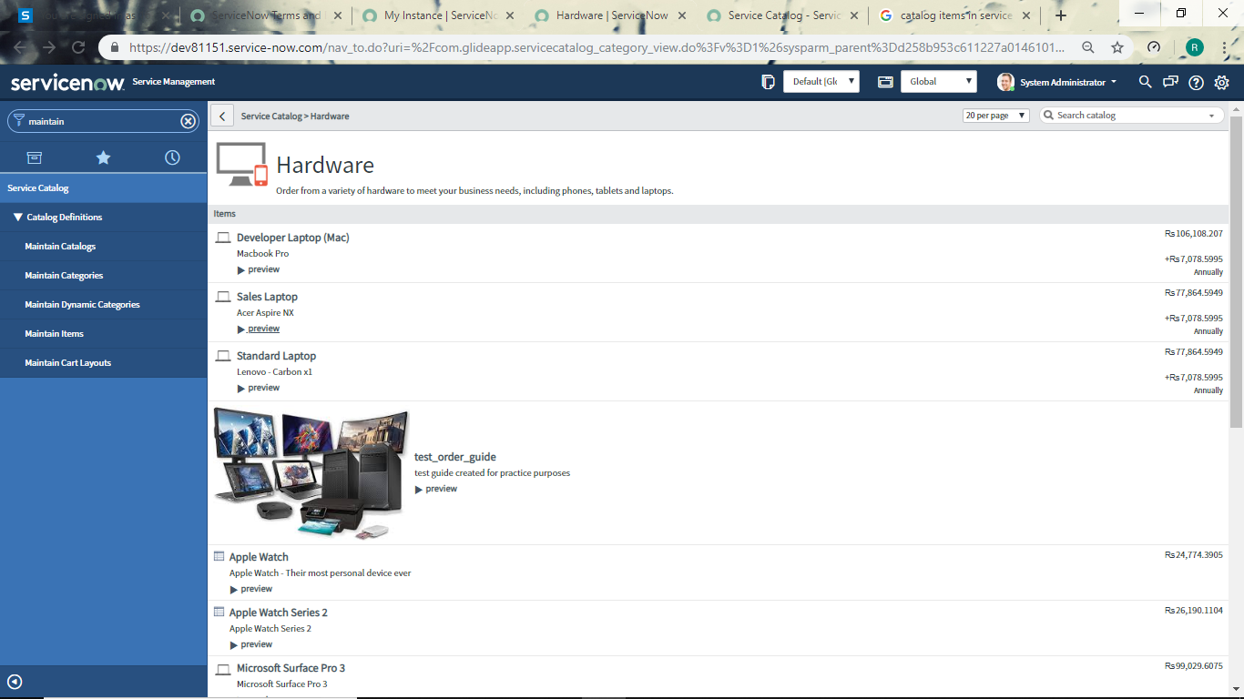

Figure 13 Catalog Items of category:Hardware

1. **Record Producer(sc_cat_item_producer):** These are used to create Task records from the Service Catalog. Also they can be applied to any of the table and link can be provided from portal.
2. **Variable Set (item_option_new_set) :** Group of variables shared between catalog items are called variable sets. A catalog items generally has some fields in which its data is stored. These fields are called variabes of the catalog item. Variable sets are collections of fields that can be directly linked with catalog item rather than one by one creation of variables.
3. **Execution Plan (sc_cat_item_delivery_plan):** Execution Plans defining how to procure, configure and install Catalog Items.
4. **Order Guide (sc_cat_item_guide):** Guides to order multiple related Catalog Items as a single request

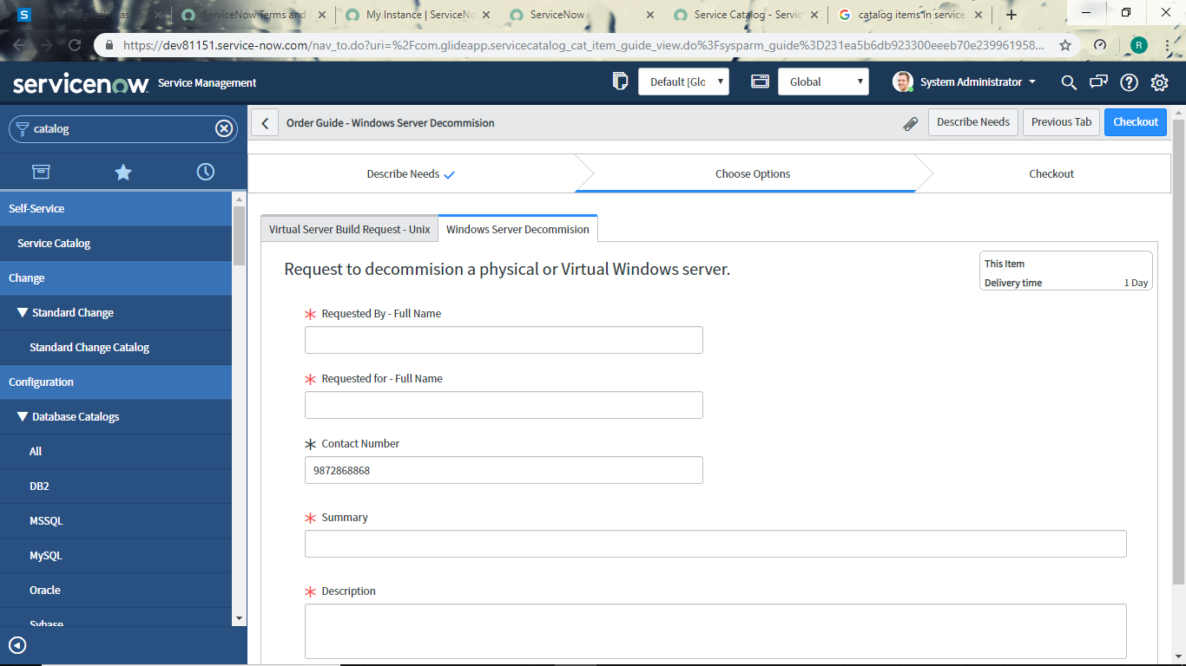

Figure 14 Order Guide

1. **Workflow (wf_workflow):** Controls for automating multi-step processes with a sequence of activities. Workflow provides a drag-and-drop interface for automating multi-step processes across the platform. Each workflow consists of a sequence of activities, such as generating records, notifying users of pending approvals, or running scripts. The graphical Workflow Editor represents workflows visually as a type of flowchart. It shows activities as boxes labeled with information about that activity and transitions from one activity to the next as lines connecting the boxes.

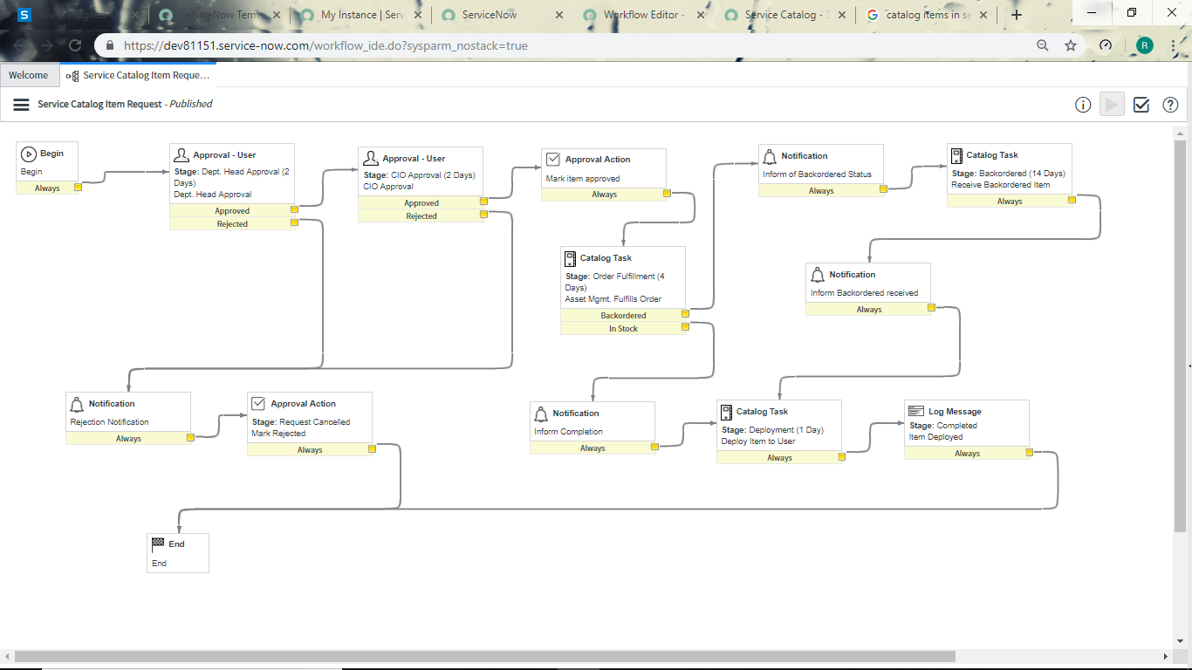

Figure 15 Workflow: For a catalog item

1. **SLA:** Provides the deadlines for completion of a task. Any action to be undertaken on incompletion of the task is also given in this section. An SLA definition record defines the timings, conditions, workflows, and other information required to create and progress task SLAs. For example, the default Priority 1 resolution (8 hour) SLA Definition defines the Task SLAs to attach to incidents with a P1 - Critical priority, specifies appropriate conditions for those Task SLAs, and uses the default SLA workflow to create events such as to send a notification, when an incident's Task SLA reaches 50% of its allotted time.

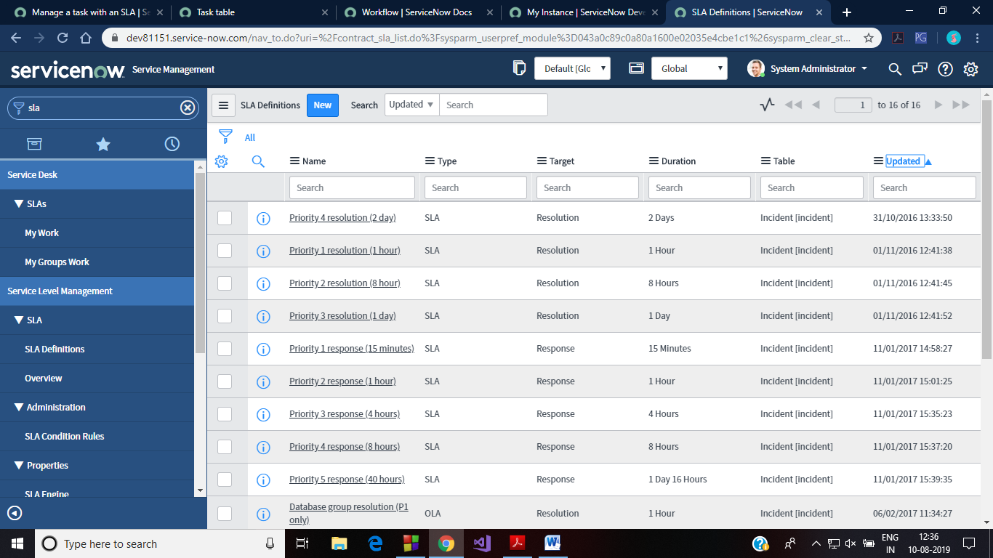

Figure 16 Default SLAs based on incident's priority

1. **Incident Management:** The goal of Incident Management is to restore normal service operation while minimizing impact to business operations and maintaining quality. Issues like any hardware fail, system hanging, access to service, infrastructural damage, or any other kind of issue that disrupts the normal functioning of an organizational employee can be raised as an incident. Any user can record an incident and track it through the entire incident life cycle until service has been restored and the issue has been resolved. ServiceNow Incident Management supports the incident management process in the following ways.

* Log incidents in the instance or by sending email.
* Classify incidents by impact and urgency to prioritize work.
* Assign to appropriate groups for quick resolution.
* Escalate as necessary for further investigation.
* Resolve the incident and notify the user who logged it.
* Use reports to monitor, track, and analyze service levels and improvement.

The default incident table is provided as below:

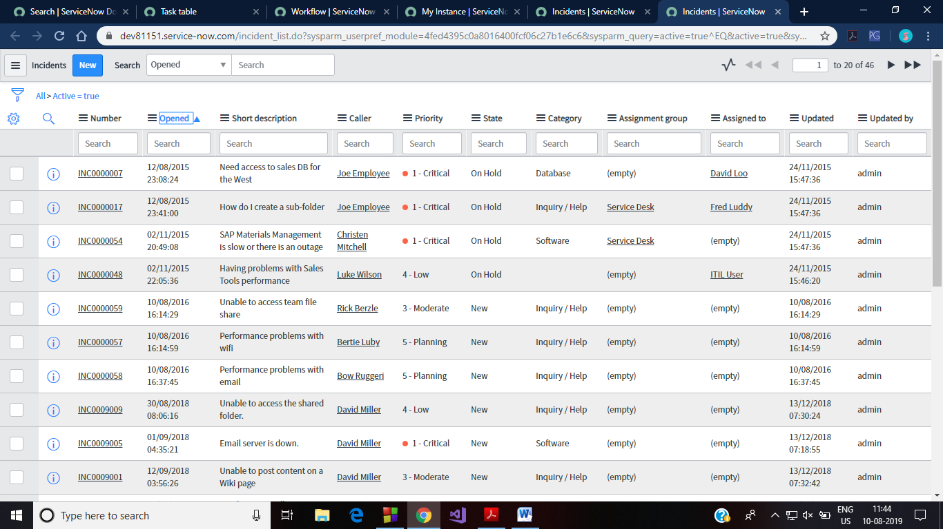

Figure 17 Incidents Table (short descriptions give idea about which are the issues for which incidents are raised)

1. **Tasks:** Task Table is an important table in ServiceNow as it stores the information about various tasks generated in an internal organization. This table can store the description of the task, current status of the task, who created the task, to whom is the task assigned, priority, impact and urgency of task etc. It provides a series of standard fields used on each of the tables that extend it, such as the Incident [incident] and Problem [problem] tables.

In addition, any table which extends task can take advantage of task-specific functionality for driving tasks. The task table is as shown in the figure.

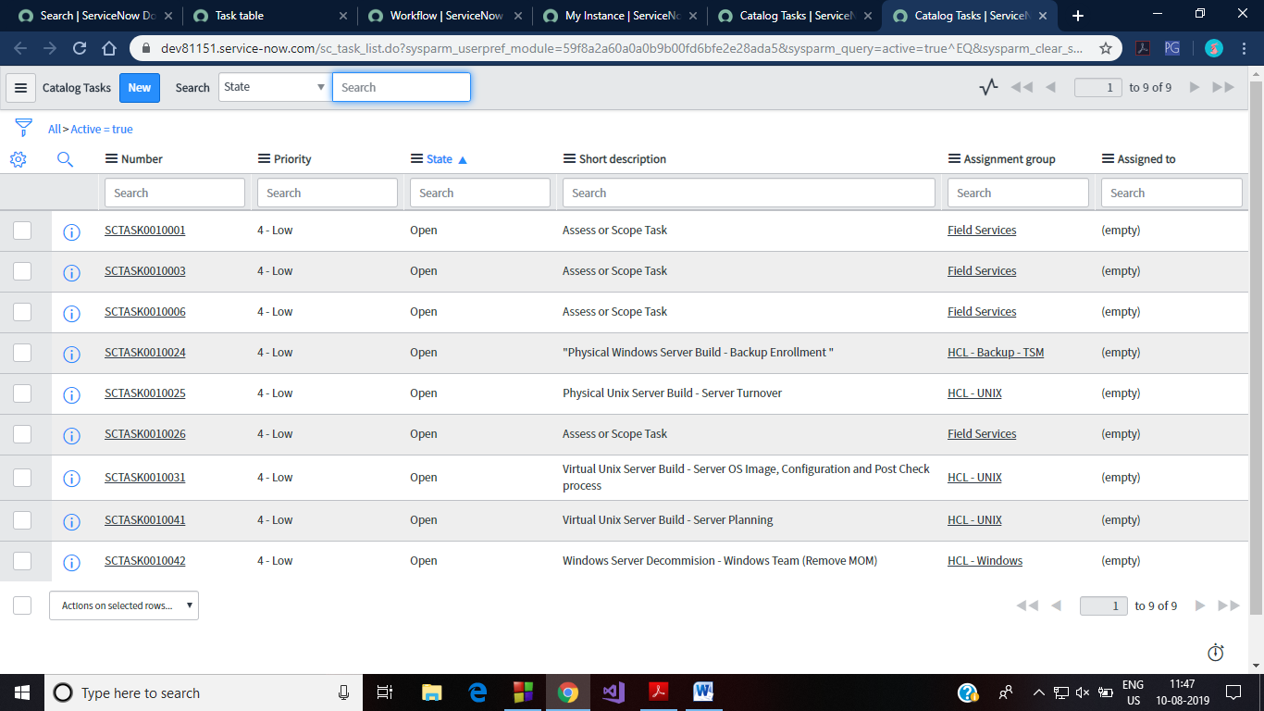

Figure 18 Tasks Table

1. **Requested Items:** Requested items table in ServiceNow instance displays the currently requested items (catalog items) of the user. The information about the quantity, item’s name, item’s category, further specifications of order given by user and response from assigned person, item’s request date/time etc. and the workflow processing of the item ordered are stored alongside.

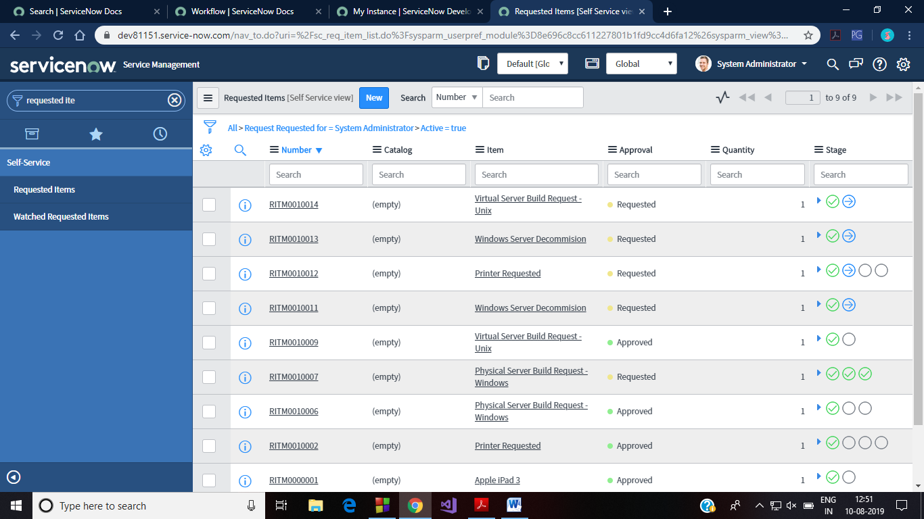

Figure 19 Requested Items Table

1. **Knowledge Base:** The knowledge base articles are used to provide some information to the users. This can be any information stored in a document type format. Some typical examples of knowledge base articles can be Employee Guidelines, instructions for using an asset etc. ServiceNow also provides some inbuilt knowledge articles maintained under different categories like Applications, Devices, Email, IT, Operating systems, suppliers etc.

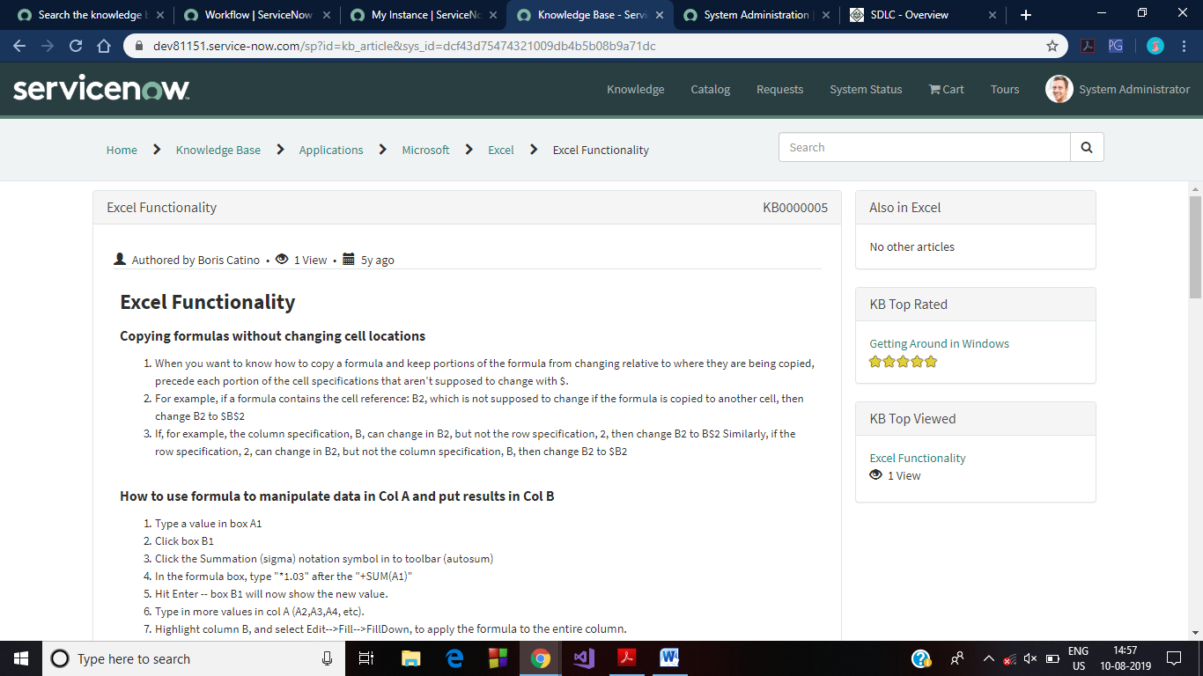

Figure 20 KB Article (about MS EXCEL)

Project

RESTAURANT MANAGEMENT SYSTEM



* **Project Goals:**
* The goal is to create such a restaurant system which will save time of both customers and restaurant management team.
* This app will work as a consumer app which allows your customers to view the restaurant menu, add feedback and read stories or review of other customers. It will also work to manage employees, maintain the entire kitchen and be a bookkeeper.
* With this system when customers can order food, order’s copy will go to kitchen and manager or cash counter immediately.
* With this system one can store entire restaurant menu, in a synchronized manner where every item is in particular category and these categories are updated and deleted by the manager or any technical consultant.
* **Why we need this system?**
* In our current situation we face few troubles like misunderstanding while we order food (from customer’s point of view).
* Doubts on waiters (misreading of the order).
* To say Goodbye to paper feedback forms.
* To take strict action if any order is not delivered in a particular time interval.
* **Project Analysis**
* User login Options.
  1. Table Number: Customers will get their ordering device on the table. Their instance will be logged in with the ID of the table they are sitting on.
  2. Chef: Each group head of chef will have their device so that hey can check what orders to be cooked.
  3. Manager: Manager’s device will keep track of all the activities and generate bill after order is completed
* Menu, Price of items, Food Selection and order option: All these are stored in as ’Menu Items’>’Categories’>’Catalog Items’.
* Order flow to kitchen and cash counter: This operates with the help of the workflows.
* Bill Receiving System: Manager gets a task to generate the bill and get it collected from the customer.
* **Working of the project:**

The customer will get the following screen on their device. This is the logged in portal for type Table user. Currently Table1 is logged in as in the top right corner of the page. Here, we have the following widgets:

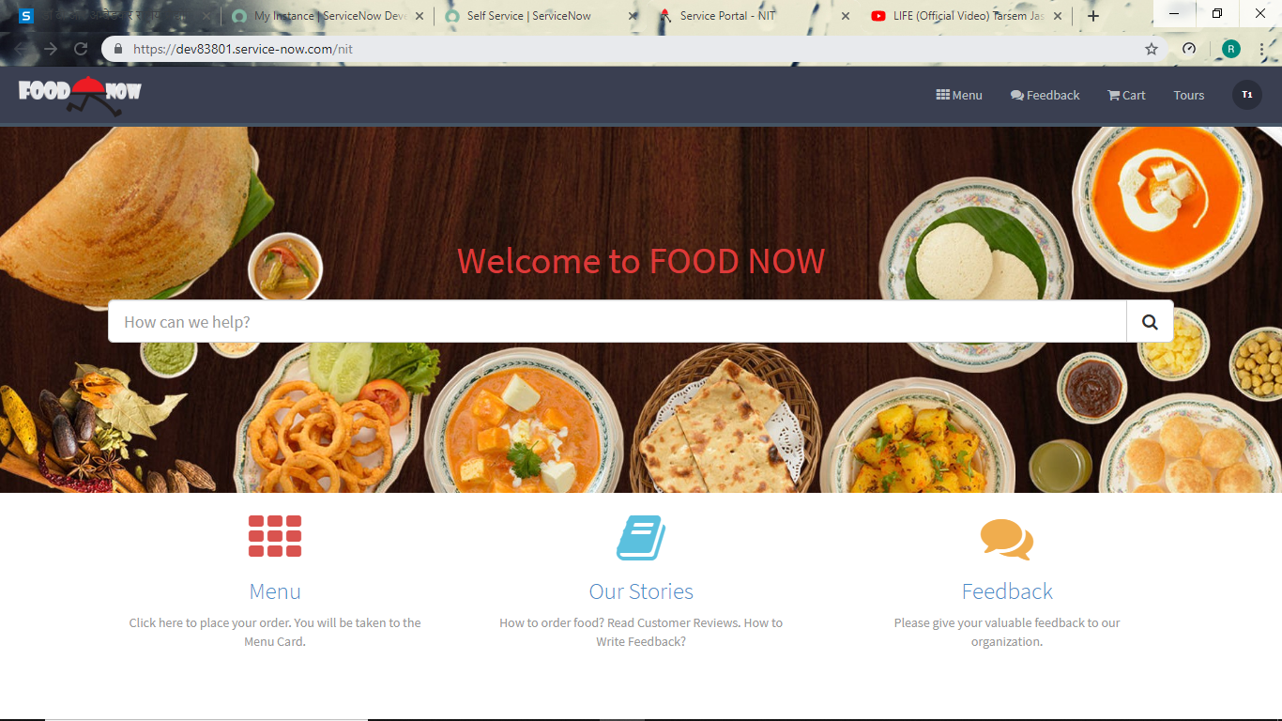

Figure 21 Logged in page for user type:Table

1. **Search bar:**  Search bar can be used to creating incidents (like when some dish gets spilled on the table or some false order received etc.), ordering food directly without going through complete menu or read some knowledge article.
2. **Menu icon:** This menu icon takes the user to the restaurant menu. This menu will be discussed in the later part.
3. **Our Stories:** This takes us to a few knowledge articles. There are knowledge articles about how to order the food, how to leave feedback and some reviews about the restaurant by previous customers.
4. **Feedback:** This icon leads the customer to the feedback form. Users can add their valuable feedbacks here.

On this screen, the user will select the Menu icon. This will lead to the following webpage that shows some most popular food items and the food categories.

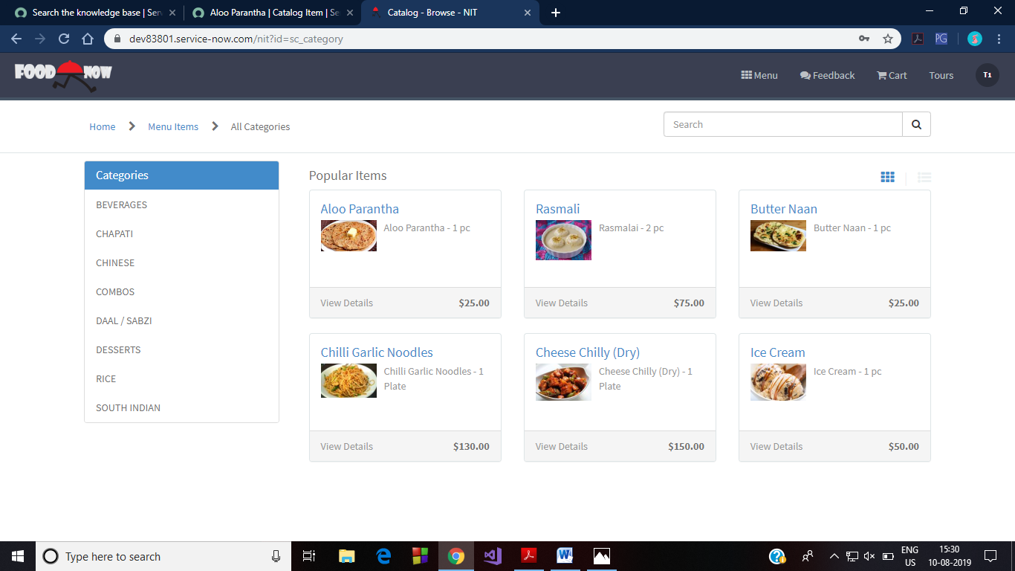

Figure 22 Menu items: Categories and popular items

In this page, on the left side are the food item categories. Popular items include the catalog items that have been ordered the most by the customers. Clicking on the category will show the catalog items related to that category. Following are the screenshots of these categories:

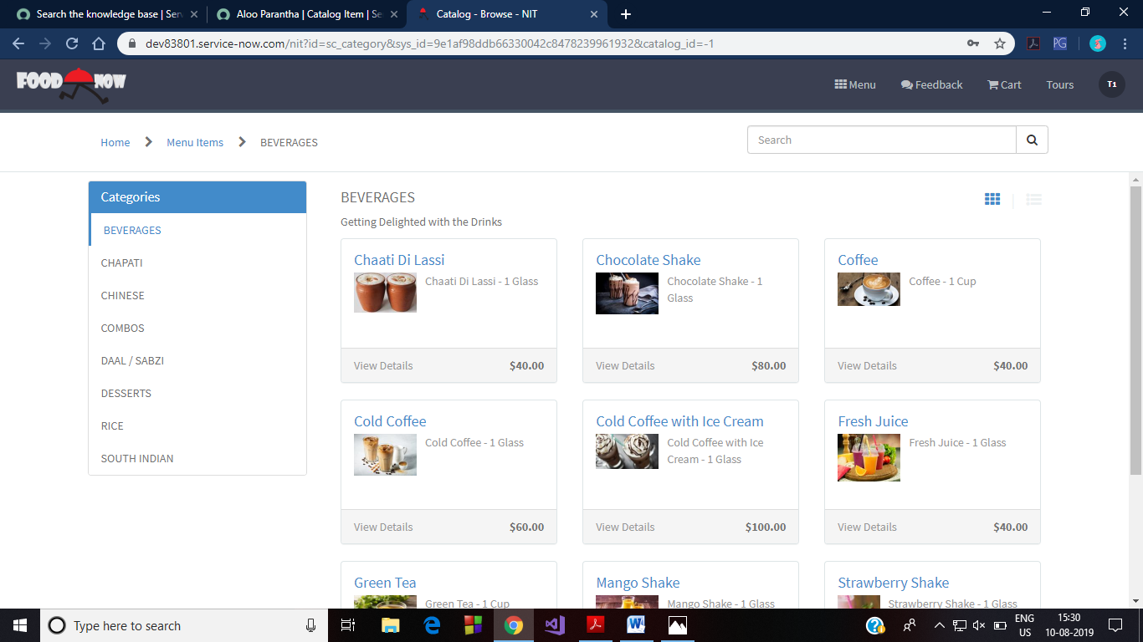

Figure 23 Beverages Category

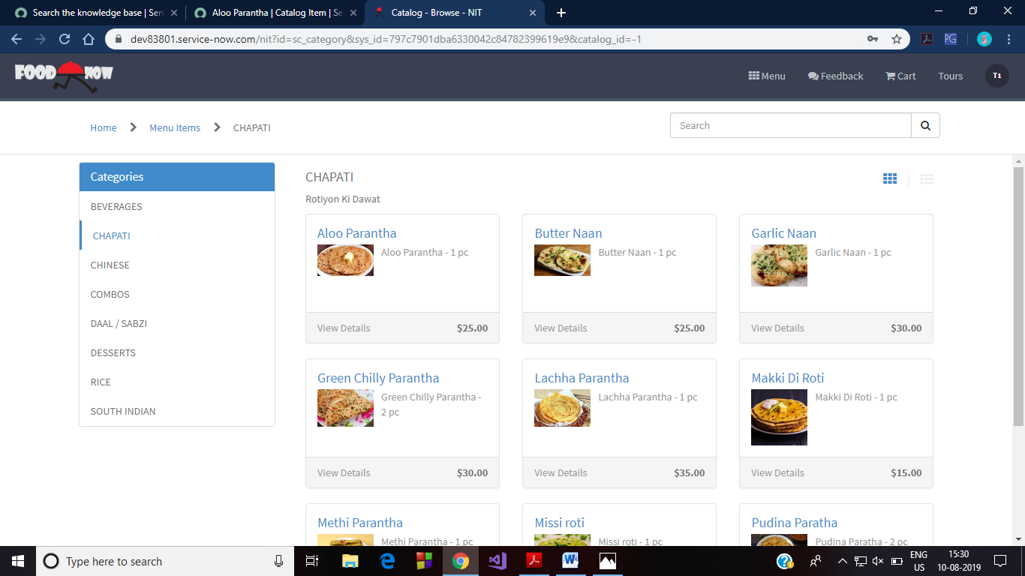

Figure 24 Chapati Category

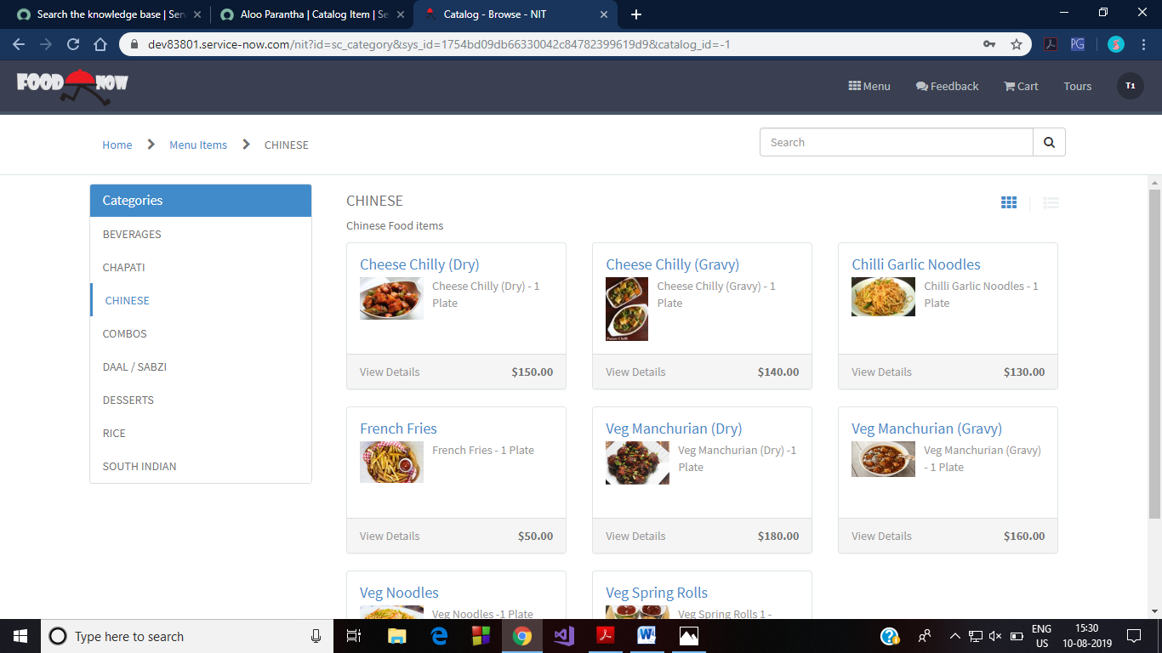

Figure 25 Chinese Category

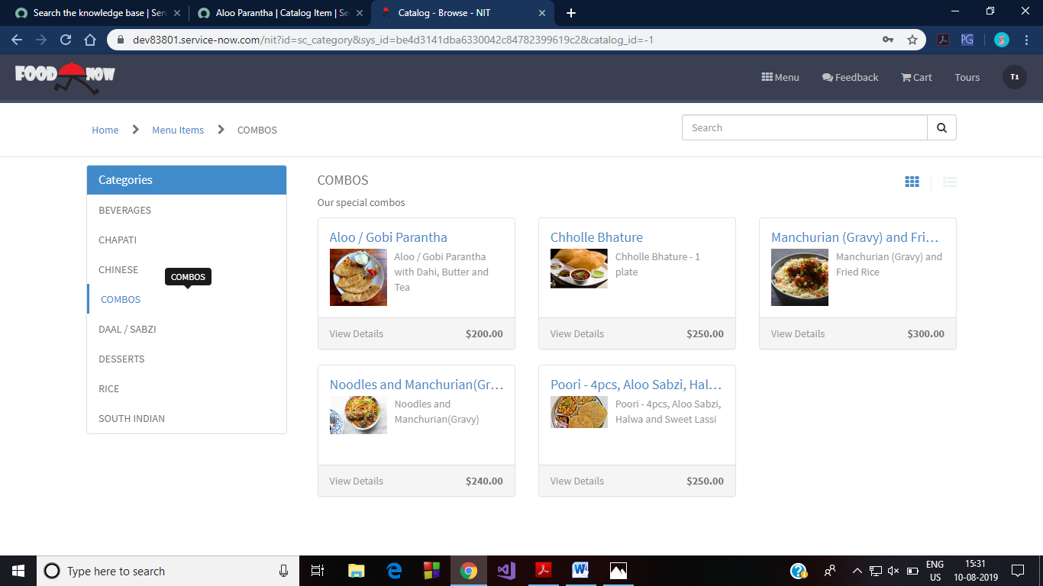

Figure 26 Combos Category

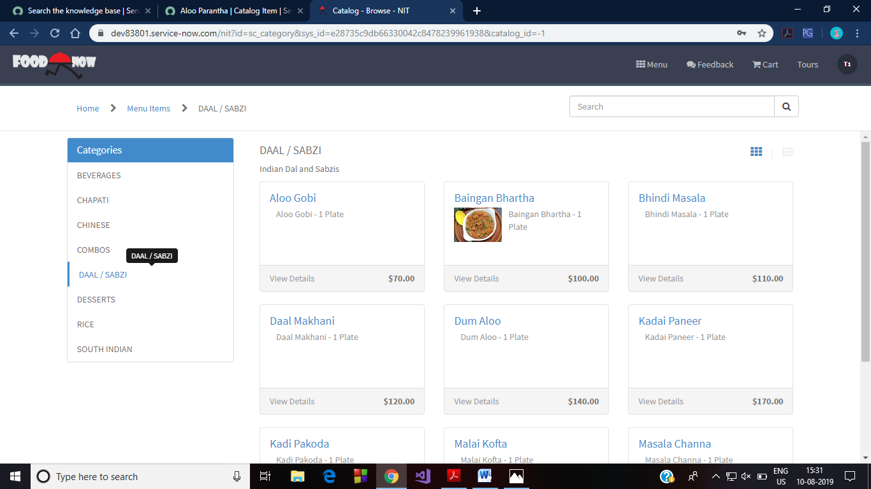

Figure 27 Daal/Sabzi Category

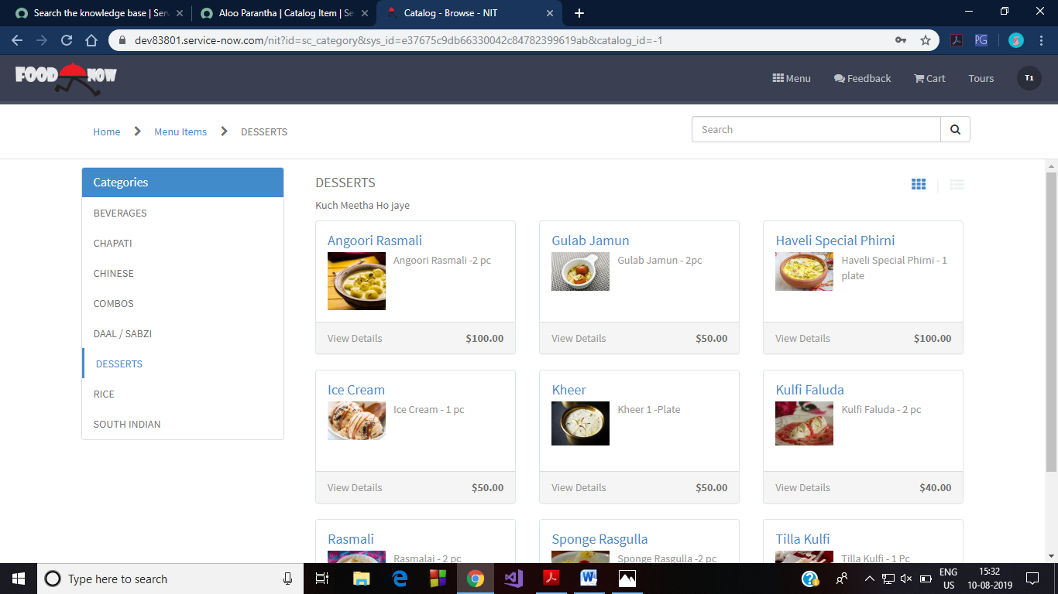

Figure 28 Desserts Category

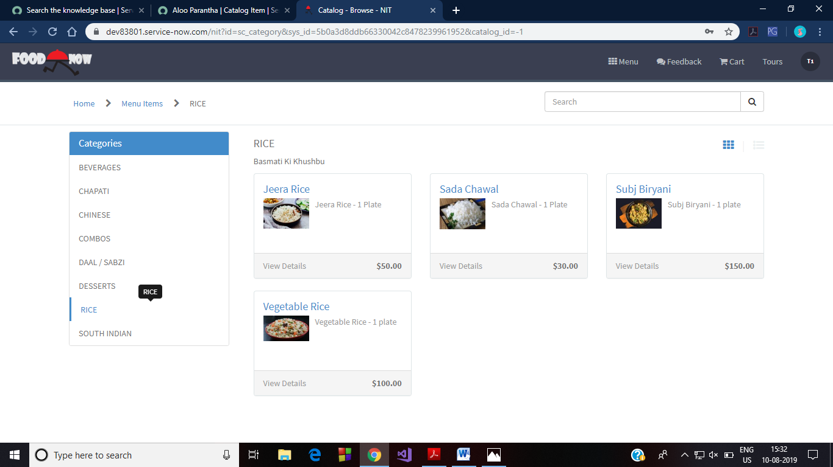

Figure 29 Rice Category

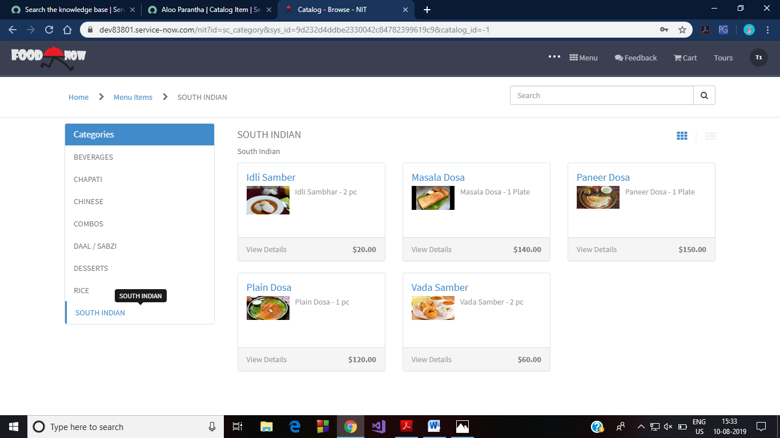

Figure 30 South Indian Category

Let’s consider that we have ordered 1 Aloo Parantha and 3 Butter Naan. For this, we select ‘Chapati’>’Aloo Parantha’ and ‘Chapati’>’Butter Naan’. This is shown below:

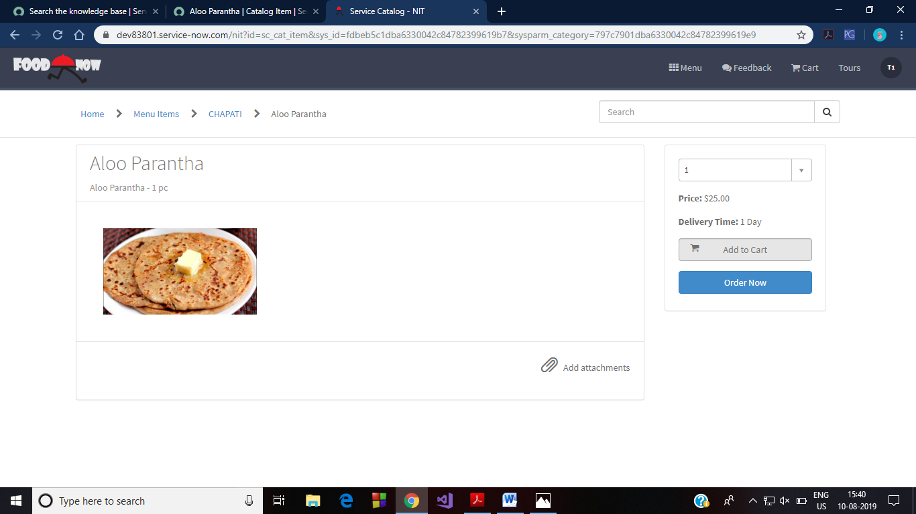

Figure 31 Aloo Parantha ordered (quantity set to 1)

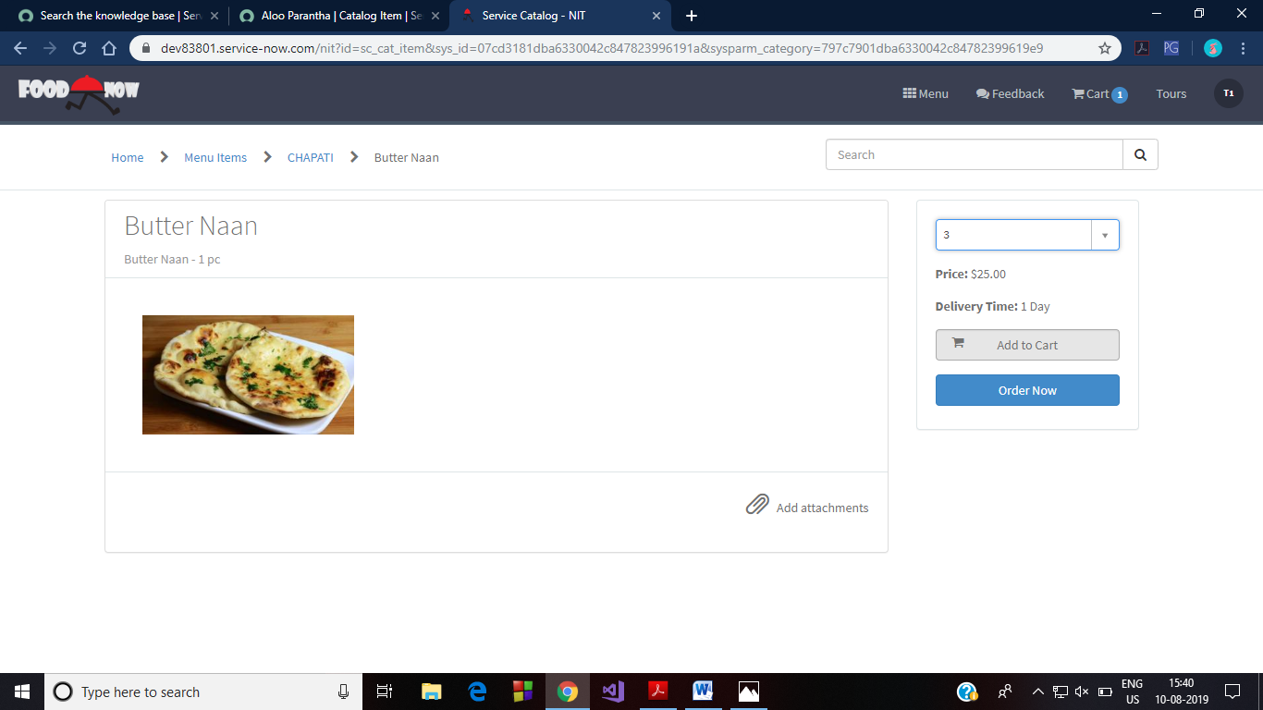

Figure 32 Butter Naan order (quantity set to 3)

Further, the order is placed by clicking on Cart menu. There we can view our orders. Click on Proceed to Checkout.

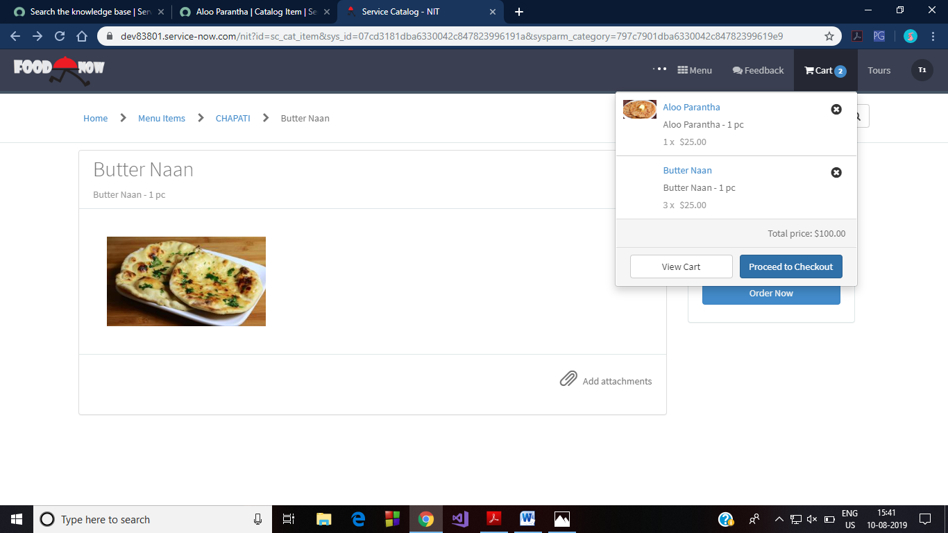

Figure 33 Cart viewed in Header Menu

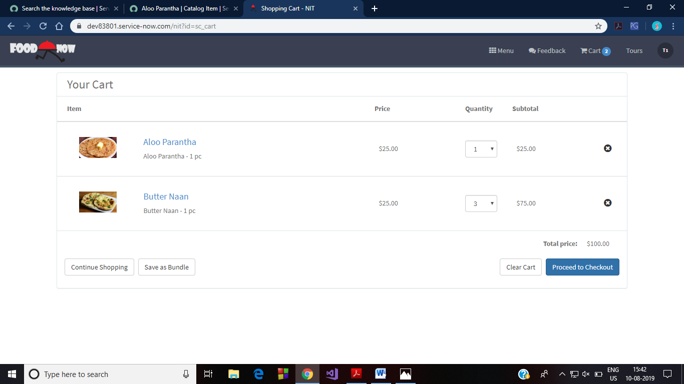

This generates a popup that asks you to add further specifications. Clicking on ‘Proceed’ finally places the order.

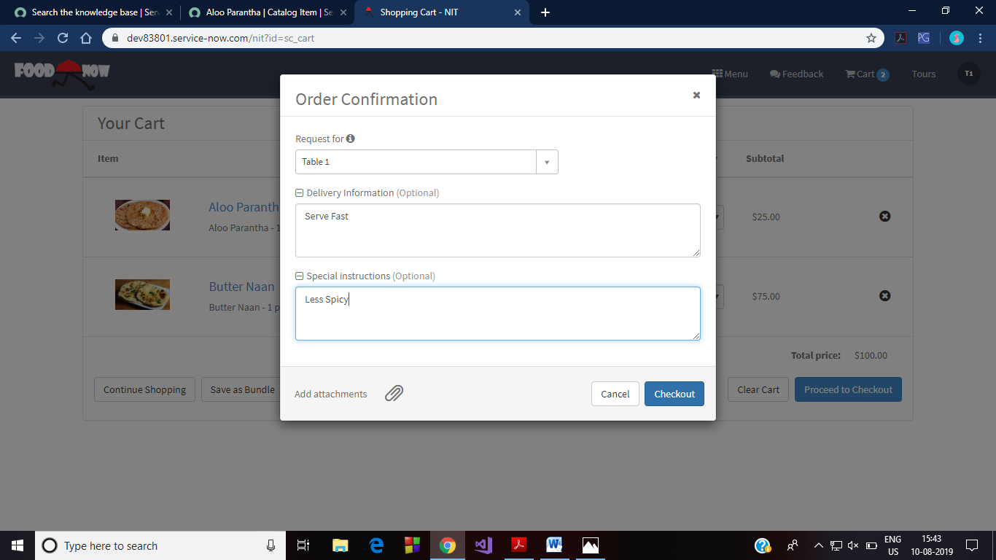

Figure 34 Giving specifications and placing order

The order has now been placed. This creates the task for the corresponding chef. Now the order has gone to the chef as per the category of the item ordered. After the chef logs in, in the Orders menu in the header bar, there will be an entry corresponding to each item of the order. The chef can start preparing the order seeing the quantity and the item name. The chef login screen and the order menu in the header bar are shown in the figure. Quantity can be seen by clicking on the request.

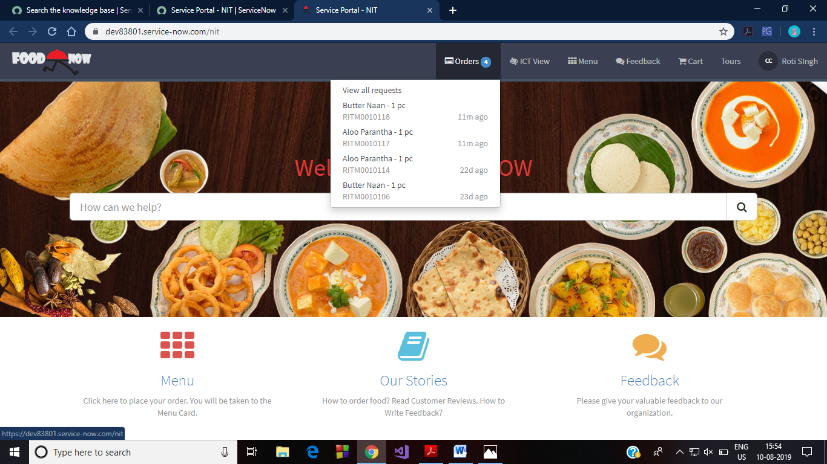

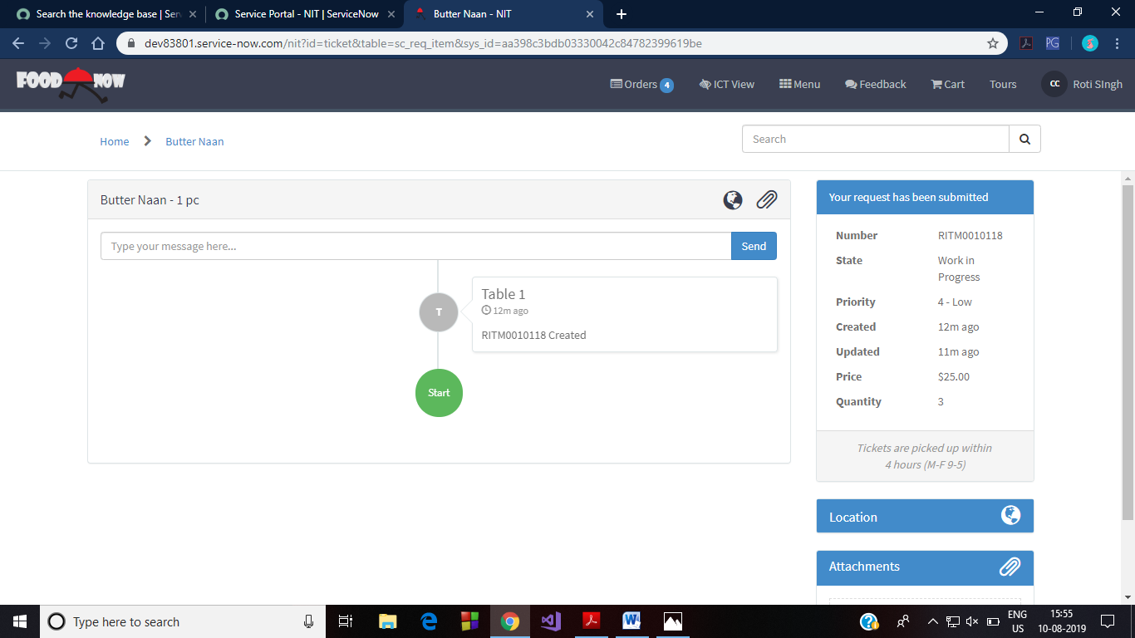

Figure 35 Observe the quantity in right block

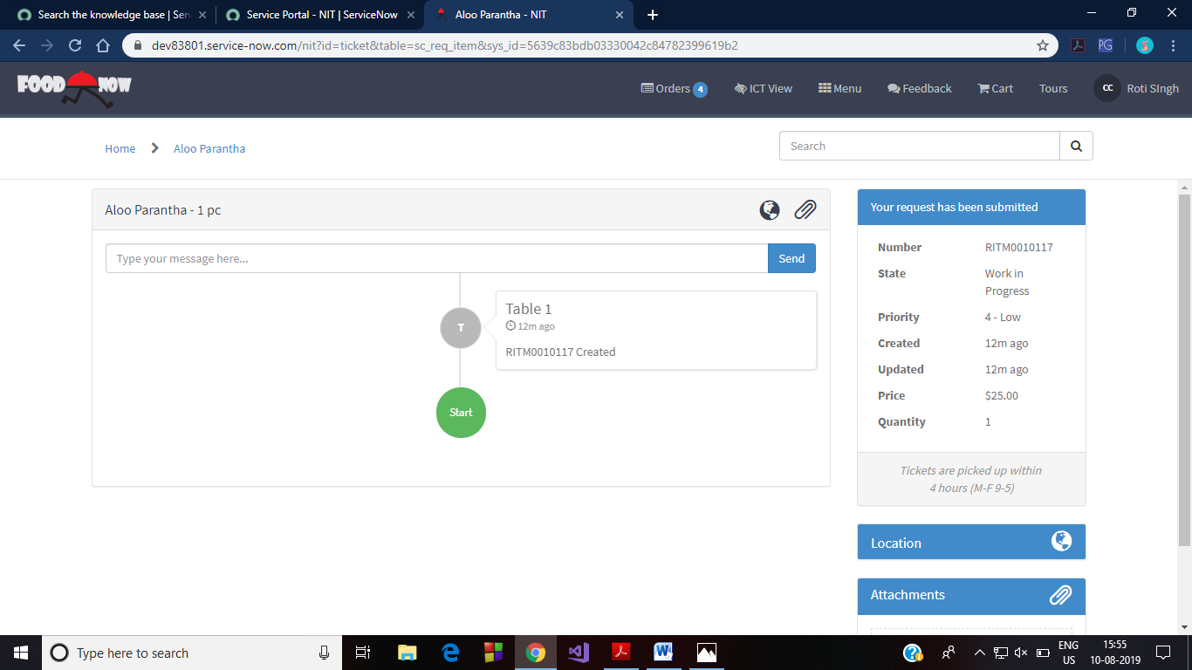

Figure 36 Observe the quantity in right block

After preparing the order, the chef has to open ICT view in the header menu. Then select My Tasks from navigator menu.

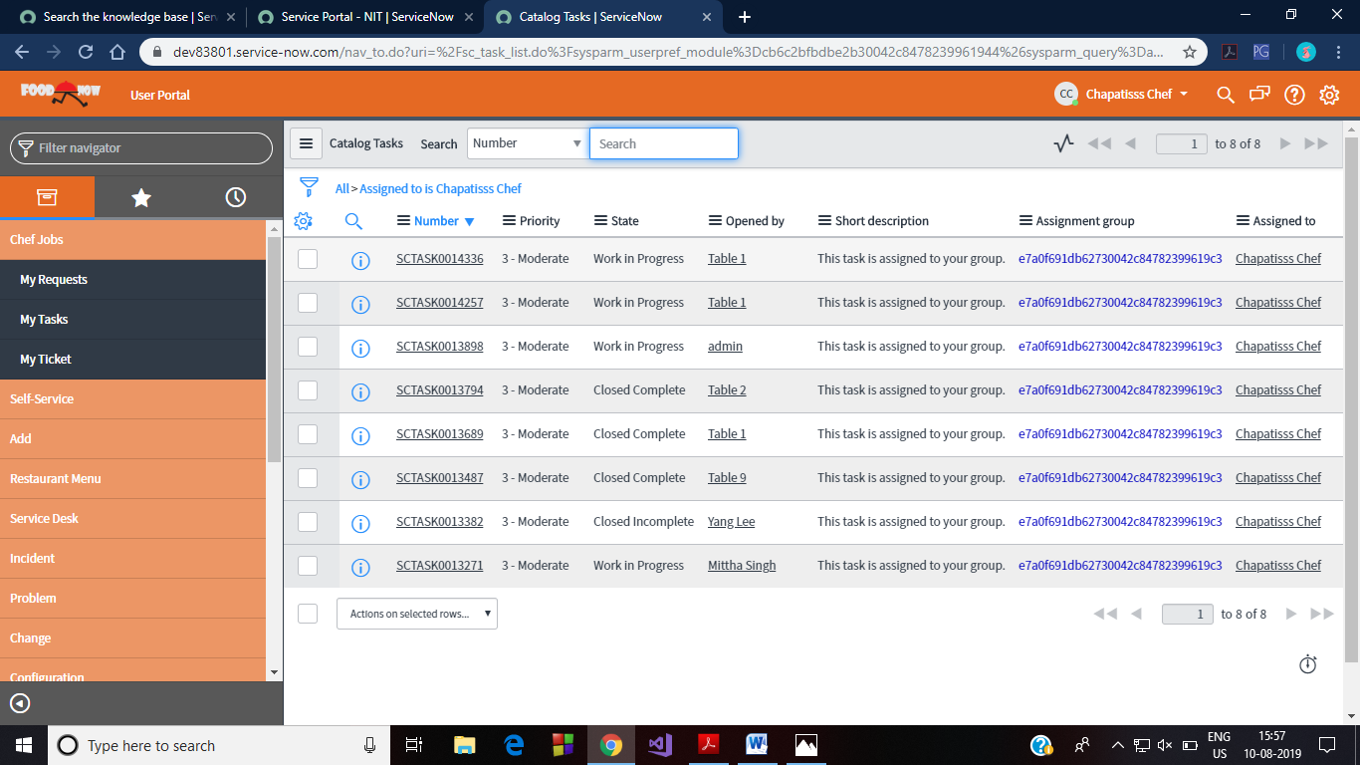

Here the chef has to select the item prepared and then change its state to close complete or directly close task. The manager gets a task to generate for that table.

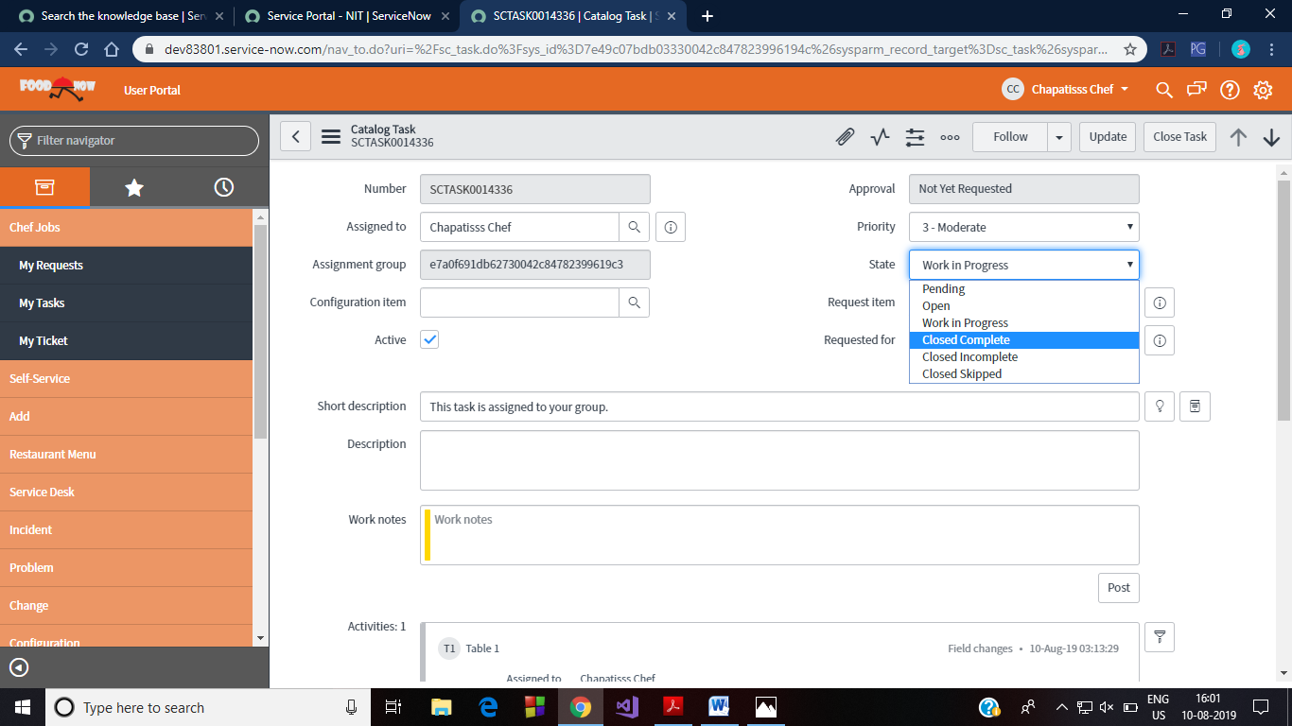

Figure 37 Closing the task of prepared dish by the chef

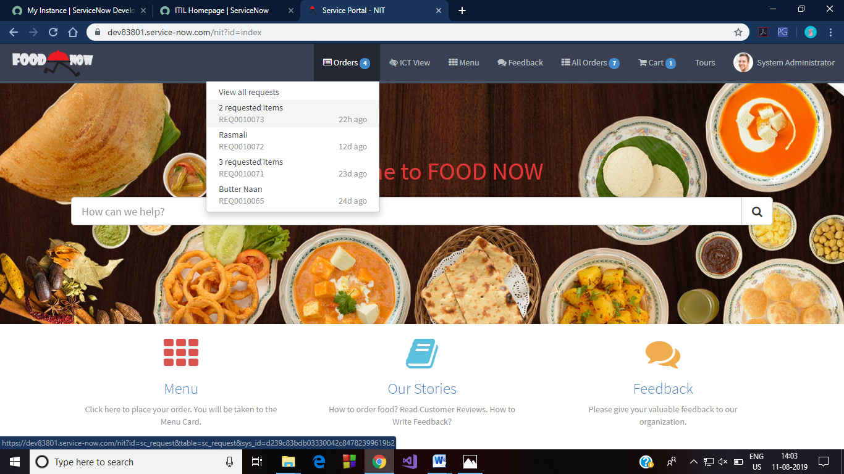Figure 38 Logged in as manager(system administrator role)

In manager’s logged in header menu, each of the order gets displayed. Based on this information, the manager will get create the bill and send it to the corresponding table. This process is as explained in the following figure.

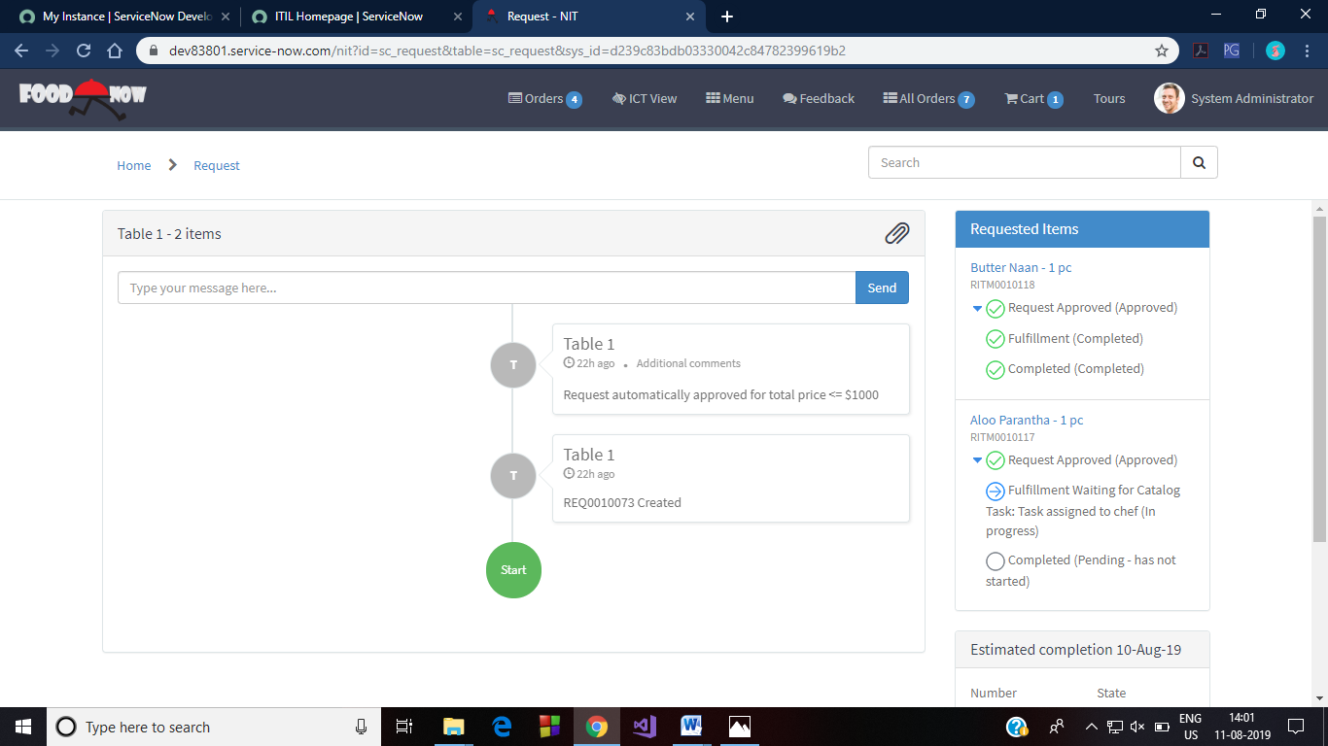

Figure 39 Order details for Tabe number1

This completes the normal functioning of the application. Now moving on to some of the left over parts of project’s implementation.

* **Workflows**

Some workflows are also used for the successful implementation of this project. These are discussed below:

1. **Chef Assignment Workflow:**

For food items ordered of different categories, we have different workflows that assign the food item to the chef of the corresponding category. Here one such category is shown. In total, there will be nine similar workflows related to each category. Similar are the workflows for all other categories.

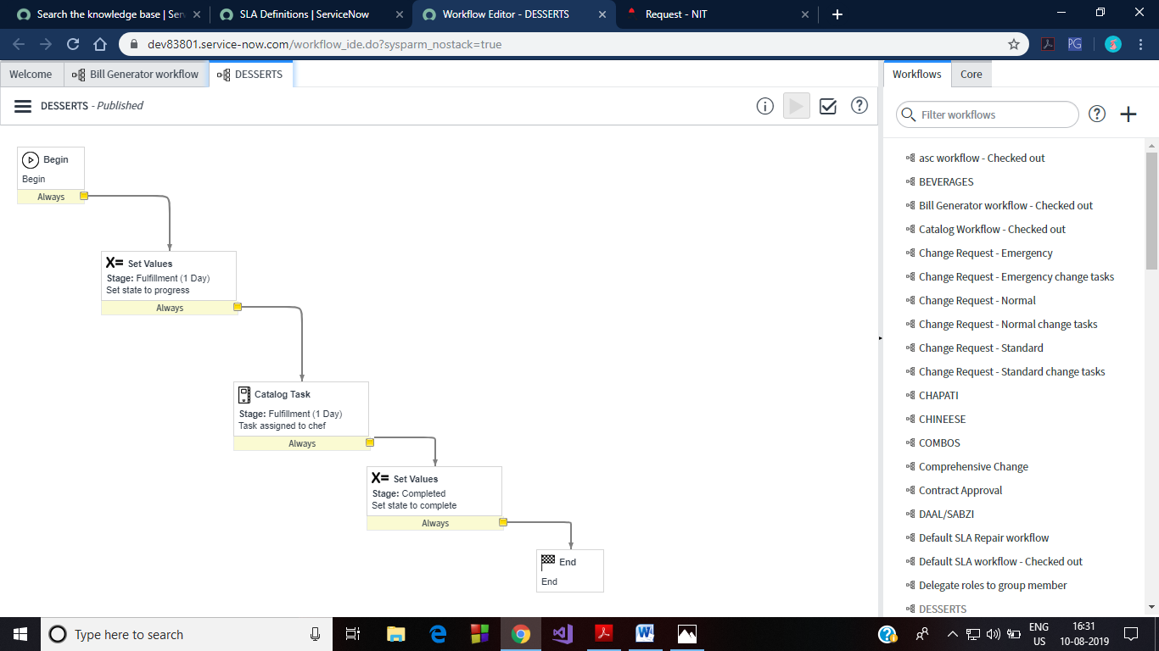

Figure 40 Workflow that assigns order of dessert category to chef of same category

1. **Bill Generator Workflow:**

Also as soon as the order is given by the customer, the manager gets a task to generate and send bill to corresponding table. This is accomplished by using a workflow. We have named this workflow as Bill Generator Workflow.

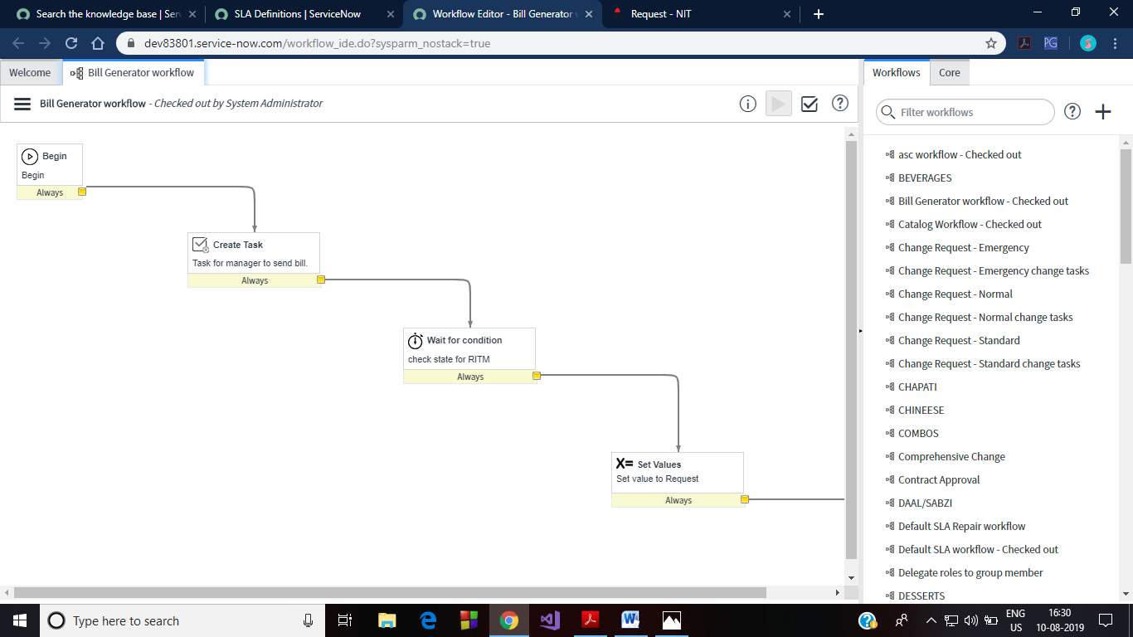

Figure 41 Workflow that creates task for manager to generate the Bill.

1. **Restaurant SLA 2:**

This workflow is linked to an SLA that keeps record of the time for which the order has been placed. If until the certain time (30 minutes), if the task is not closed completed by the chef, the manager receives the notification about the same and can take the required action. The SLA related to this is discussed as below.

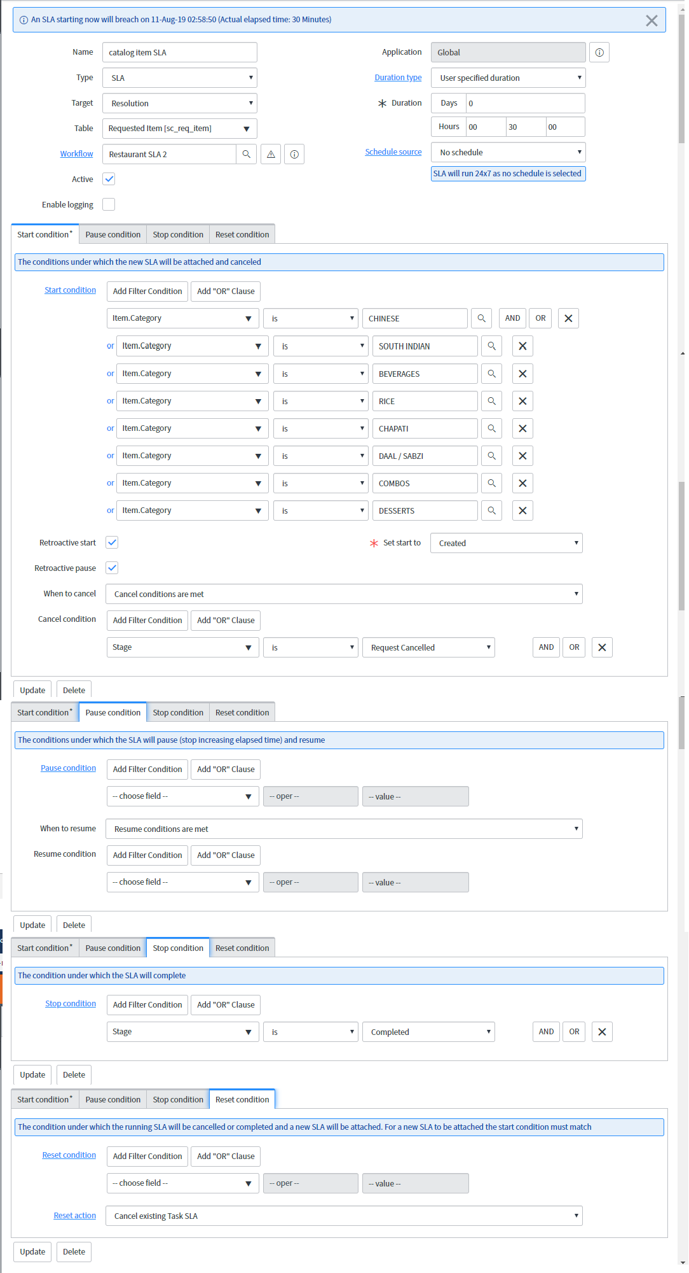

Figure 42 SLA for catalog items

* **Catalog Item SLA:**

This SLA takes care of the time in which the chef prepares the dish and change status to ‘closed complete’. If the status is not changed by the chef within the set time (i.e. 30 minutes), then SLA breach will occur and based in that the manager will get a notification that a certain chef is not performing the assigned task. Thereafter, the manager can take the required action. This SLA is shown as in figure 42.

* **Feedback:**

Receiving feedbacks from the customer to improve the service is really important for any restaurant. For this task, there is a feedback icon on the table login screen. The customers can click that icon to fill the feedback form as displayed in the figure.

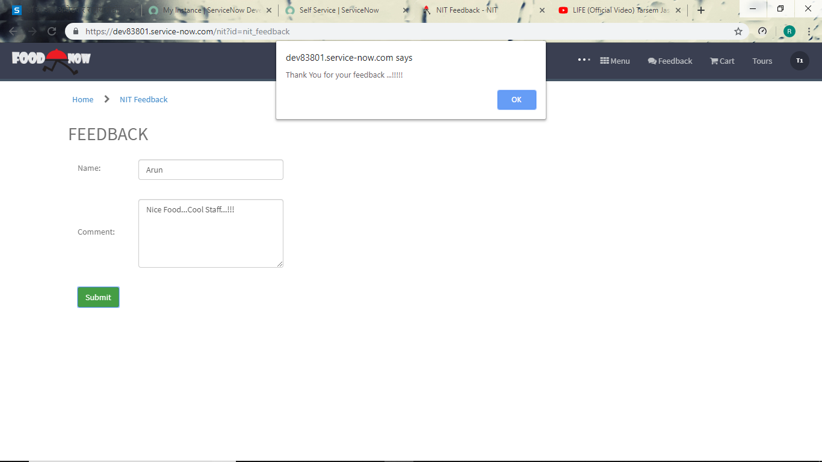

Figure 43 Feedback form submitted by the customer

Once the customer submits the feedback, this creates a record in the feedback table that includes the name of the customer and the comments given by that customer.

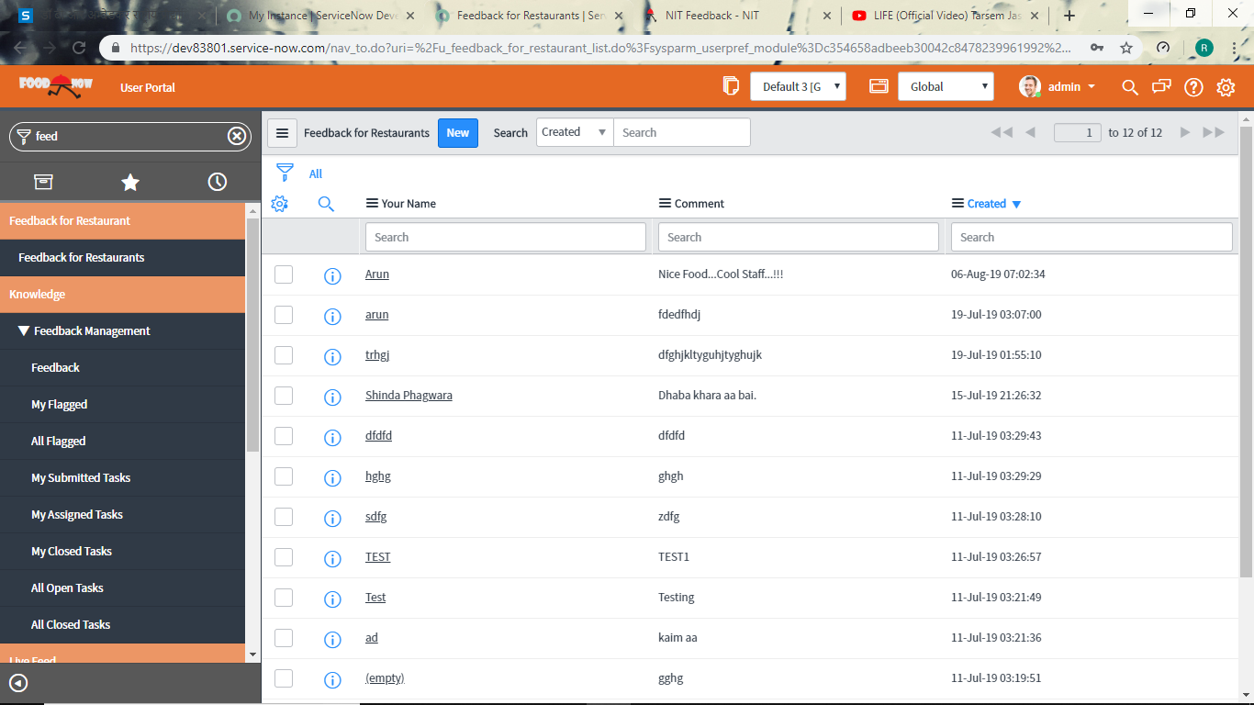

Figure 44 Feedback Table viewed by manager in native view

* **Backend tables:**

1. **User table**: The ServiceNow provided out of the box user table is used to store the data related to all the users. However the create new user form is modified and the fields of our need are added. This can be discussed by explaining the process to create new table. The users can be of three types:
2. Table: The table as a user is for the usage of customer. The customer gets a tablet or such device on the table which is in logged in as Table ID. This helps in identification of the table number that has placed a certain order and the order can be delivered to correct customer.

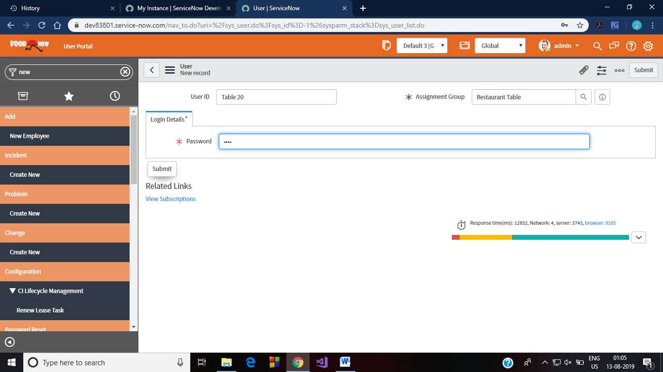

1. Chef: The chef who has to receive orders and update their orders’ status to ’closed complete’ when these are completed/prepared. The group chef is divided into subgroups based on what category the chef belongs to.

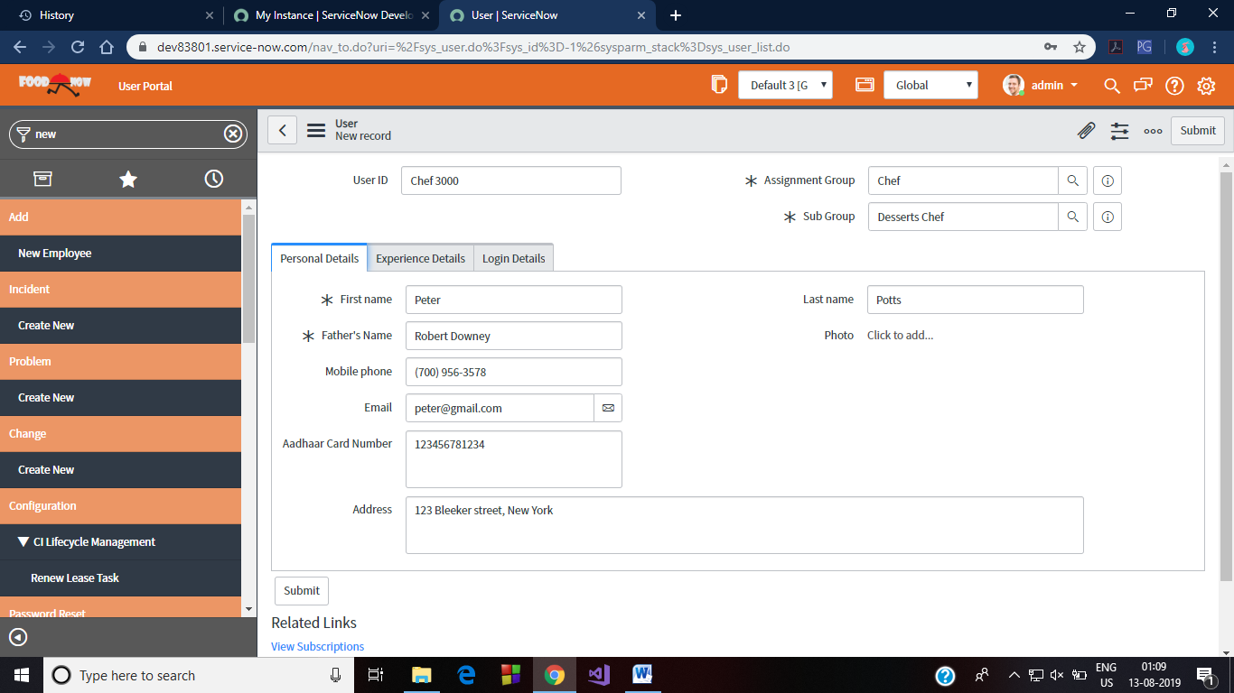

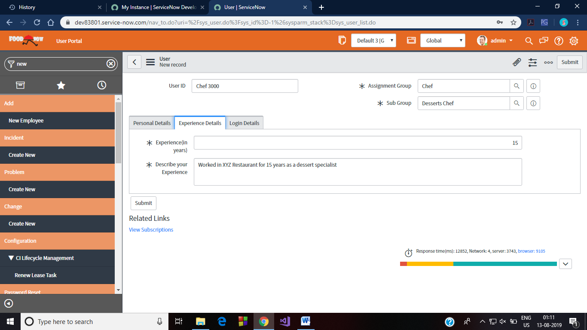

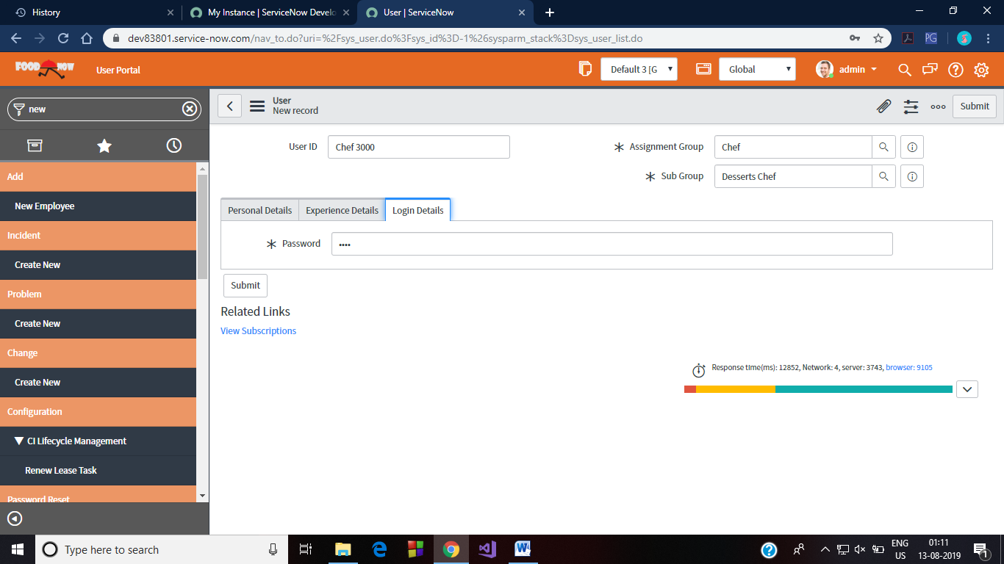

1. Manager: The manager has the right to view everything. This includes knowing which chef is working on which order, which table is occupied yet. The feedback table can be viewed by the manager. Also the notification about the inactivity of some chef is received by the manager.

All these user groups get different kind of forms while a creating a new user of that group. This is based on what type of credentials is required. This can be explained by following:

1. Requested Items: This table is used to store the requested items i.e. orders of a particular user. A customer can view his/her orders using this table. This table is also an out of box functionality of ServiceNow.
2. Task Table: This table is used by the chef to store the pending tasks and close them on their completion. This is an out of box functionality of ServiceNow.

**

Figure 45 Task table for Chef

1. Feedback_for_restaurant: This table is created to store the data about the feedbacks that were submitted by the customers. Manager can view this table in Native view.



Figure 46 Restaurant Feedback table

**BIBLIOGRAPHY**

1. [www.youtube.com](http://www.youtube.com)
2. [www.tutorialspoint.com](http://www.tutorialspoint.com)
3. [www.w3schools.com](http://www.w3schools.com)
4. [www.docs.servicenow.com](http://www.docs.servicenow.com)
5. [www.asolutionscorp.com](http://www.asolutionscorp.com)
6. [www.google.com](http://www.google.com)